DESIGN AND ANALYSIS OF DUAL BAND PATCH ANTENNA USING FOR WIRELESS APPLICATIONS

A PROJECT REPORT

Submitted
In partial fulfillment of the requirements for the award of

BACHELOR OF TECHNOLOGY
IN

ELECTRONICS & COMMUNICATION ENGINEERING

BY

M. PAVAN SWAROOP REDDY (16761A04F6)

N. MARY STELLA (16761A04F7) SK. AMEER HUSSAIN MAAZ (17765A0433)
A. NAGA SAI KUMAR REDDY (16761A04C2)

Under the Guidance of

Mr. P. RAKESH KUMAR
Sr. Asst. Professor


DEPARTMENT OF ELECTRONICS & COMMUNICATION ENGINEERING
LAKIREDDY BALI REDDY COLLEGE OF ENGINEERING
(AUTONOMOUS)
- B. Reddy Nagar, Mylavaram – 521 230.
Affiliated to JNTUK, Kakinada & Approved by AICTE, New Delhi Accredited by NBA and NAAC
Certified by ISO 9001-2015
2016-2020

DESIGN AND ANALYSIS OF COMPACT ULTRA WIDEBAND MICROSTRIP PATCH ANTENNA USING DEFECTED GROUND STRUCTURE FOR WIRELESS APPLICATIONS

A PROJECT REPORT

Submitted
In partial fulfillment of the requirements for the award of

BACHELOR OF TECHNOLOGY
IN

ELECTRONICS & COMMUNICATION ENGINEERING

BY

- PAVAN SWAROOP REDDY (16761A04F6)

MARY STELLA (16761A04F7) SK. AMEER HUSSAIN MAAZ (17765A0433)
A. NAGA SAI KUMAR REDDY (16761A04C2)

Under the Guidance of

Mr. P. RAKESH KUMAR
Sr. Asst. Professor


DEPARTMENT OF ELECTRONICS & COMMUNICATION ENGINEERING
LAKIREDDY BALI REDDY COLLEGE OF ENGINEERING
(AUTONOMOUS)
L. B. Reddy Nagar, Mylavaram – 521 230.
Affiliated to JNTUK, Kakinada & Approved by AICTE, New Delhi Accredited by NBA and NAAC
Certified by ISO 9001-2015
2016-2020

LAKIREDDY BALI REDDY COLLEGE OF ENGINEERING
(AUTONOMOUS)
- B. Reddy Nagar, Mylavaram – 521 230.
Affiliated to JNTUK, Kakinada & Approved by AICTE, New Delhi Accredited by NBA and NAAC, Certified by ISO 9001-2015

DEPARTMENT OF ELECTRONICS & COMMUNICATION ENGINEERING



CERTIFICATE

This is to certify that Project work entitled “DESIGN AND ANALYSIS OF COMPACT ULTRA WIDEBAND MICROSTRIP PATCH ANTENNA USING DEFECTED GROUND STRUCTURE FOR WIRELESS
APPLICATIONS” is a bonafide work done and submitted by M. PAVAN SWAROOP REDDY (16761A04F6), N. MARY STELLA (16761A04F7), SK. AMEER HUSSAIN MAAZ (17765A0433) and A. NAGA SAI KUMAR
REDDY (16761A04C2) in partial fulfillment of requirement for the award of Bachelor of Technology degree in Electronics and Communication Engineering at LAKIREDDY BALI REDDY COLLEGE OF ENGINEERING,
MYLAVARAM during the year 2019-2020.

Mr. P. Rakesh Kumar Dr. Y. Amar Babu Sr. Asst. Professor
PROJECT GUIDE Professor & HOD

EXTERNAL EXAMINER

ACKNOWLEDGEMENT

The Satisfaction that accompanies the successful completion of any task would be incomplete without the mention of people whose ceaseless co-operation made it possible, whose constant guidance and encouragement crown all efforts with success.
I humbly express my thanks to our Principal Dr. K. Appa Rao for extending his support and for providing us with an environment to complete our project successfully.
I would also like to thank our Vice Principal, Dr. K. Harinadha Reddy for encouraging us which certainly helped to complete the project in time.
I deeply indebted to our Head of Department Dr. Y. Amar Babu, who modeled us both technically and morally for achieving greater success in life.
I extremely thankful to my guide Mr. P. Rakesh Kumar, Sr. Asst. Professor, Department of Electronics and Communication Engineering, for his excellence guidance, timely and valuable suggestions and encouragement that enabled the success of the project.
I would like to thanks to the project review committee Dr. G. Srinivasulu and Dr. Y. S.V. Raman, Department of Electronics and Communication for their support and constant encouragement throughout the period of our project work for making it a successful one.
I would like to express my heart full thanks to our parents for their unflinching support and constant encouragement throughout the period of our project work for making it a successful one.
I would like to thank all the teaching and non-teaching staff members of Electronics and Communication Engineering, KL University in the process of fabrication who have extended their full co-operation during the course of our project.
I thank all my friends who helped us sharing knowledge and by providing material to complete the project in time.

PAVAN SWAROOP REDDY (16761A04F6)
- MARY STELLA (16761A04F7) SK. AMEER HUSSAIN MAAZ (17765A0433)
A. NAGA SAI KUMAR REDDY (16761A04C2)

CONTENTS
Page No

List of Figures i

List of Tables iii
Abstract v
CHAPTER 1 INTRODUCTION 1
  - INTODUCTION TO ANTENNAS 1
  - MICROSTRIP ANTENNAS 1
  - SUBSTRATES 2
  - FEEDING TECHNIQUES 3
    - Microstrip line 4
    - Co-axial feed 4
    - Aperture coupling 4
    - Proximity coupling 4
  - RADIATION MECHANISM 5
  - SIMULATION TOOL USED 7
    - Applications to HFSS 9
    - System requirements to run HFSS 9
  - FABRICATION METHODS 9
    - Photolithography process 9
    - PCB prototype modelling 10
  - AMENITIES FOR ANTENNA MEASUREMENT 11
    - Anechoic chamber 11
    - Vector Network Analyzer 12
  - DEFECTED GROUND STRUCTURE 13
  - RESEARCH MOTIVATION 13
  - OBJECTIVE OF THE RESEARCH 13
  - ORGANIZATION OF THESIS 14
CHAPTER 2 LITERATURE SURVEY 15
  - MICROSTRIP PATCH ANTENNAS 15
  - MULTIBAND MICROSTRIP PATCH ANTENNAS 15
  - WIDEBAND MICROSTRIP ANTENNAS 16
  - WIDEBAND MICROSTRIP PATCH
ANTENNAS USING DEFECTED
GROUND STRUCTURE 18
CHAPTER 3 DEFECTED GROUND STRUCTURE 21
  - INTRODUCTION TO DGS 21
  - BASIC STRUCTURE AND
TRANSMISSION CHARACTERISTICS 21
  - APPLICATIONS OF DGS 24
    - Delay lines 24
    - Antennas 25
  - CONCLUSION 25
CHAPTER 4 THEORITICAL ANALYSIS 26
  - PROPOSED DESIGN 26
  - DESIGN SPECIFICATIONS 27
    - Frequency of operation 27
    - Dielectric constant of the substrate 27
    - Height of Substrate 28
CHAPTER 5 DESIGN OF MICRO STRIP PATCH
USING HFSS 31
  - OUTLINE OF A PATCH ANTENNA 31
  - DRAWING A SUBSTRATE 33
  - PATCH 33
  - GROUND PLANE 35
  - MICROSTRIP FEED LINE 36
  - ASSIGN EXCITATION 37
  - ANALYSIS SETUP 37
  - SOLUTION SETUP 37
  - ADD FREQUENCY SWEEP 38
  - MODEL VALIDATION 38
  - ANALYZE 38
  - CONCLUSION 38
CHAPTER 6 EXPERIMENTAL RESULTS 39
  - ANTENNA DESIGN 39
    - Antenna design with square patch 39
    - Antenna design with modified patch 39
    - Antenna design with DGS 40
  - PARAMETRIC ANALYSIS 42
    - Return loss with various DGS 42
      - Antenna design with
circular slit DGS 42
      - Antenna design with
triangular slit DGS 43
      - Antenna design with
proposed DGS 43
    - Return loss curve with DGS and Without DGS 45
    - Return loss curve due to variation
in Gap (g) 45
    - Return loss curve due to variation
in inner radius R1 46
    - Return loss curve for various Substrates 46
    - Return loss curve due to variation
In Strip feed width Wf 47
  - VSWR 48
  - PEAK GAIN 49
  - SURFACE CURRENT AND FIELD
ANAYLSIS 49
  - MEASURED RESULTS AND
DISCUSSIONS 50
  - CONCLUSION 52
CHAPTER 7 CONCLUSION AND FUTURE SCOPE 53
  - CONCLUSION 53
  - FUTURE SCOPE 53

REFERENCES

List of Figures

Fig No Figure Name Page No
  - Structure of Microstrip antenna 02
  - Different feeding techniques 03
  - Radiation mechanism 05
  - Curved wire 06
  - Bent wire 06
  - Discontinuous wire 07
  - Terminated wire 07
  - Two-wire Transmission line 07
  - Photolithography Process 10
  - PCB Prototype machine 11
  - Anechoic chamber 12
  - Vector Network Analyzer 12
  - Basic DGS unit 22
  - Equivalent circuit of DGS element 23
  - Various DGS 24
  - Design of rectangular patch antenna with
DGS 26
  - Design flow of Proposed antenna 29
  - (a) Original Design of Antenna top view 31
(b) Side view 31
  - Solution type Selections 32
  - Choose of default value 32
  - (a) Drawing of substrate 33
(b) Dimensions of substrate 33
  - Patch modelling 34
  - Patch dimensions modelling 34

  - Uniting of objects 35
  - Ground formation 35
    - Ground formation with dimensions 36
  - Feed line formation 36
  - Feed line dimensions 37
  - Validations checked 38
  - Iteration-1 39
  - Return loss for Iteration-1 39
  - Iteration-2 40
  - Return loss for Iteration-2 40
  - Iteration-3 40
  - Return loss for Iteration-3 41
  - Schematic configuration of Iterations-1,2,3 41
  - Simulated return loss for different iterations (1,2,3) 41
  - Circular slit DGS 42
  - Return loss for circular slit DGS 42
  - Triangular slit DGS 43
  - Return loss for triangular slit DGS 43
  - Proposed DGS 44
  - Return loss for Proposed DGS 44
  - (a) Antenna with various DGS 44
    - Simulated return loss for various DGS 45
  - Simulated Return loss with and without DGS 45
  - Simulated return loss curves due to
variation of Gap(g) 46
  - Simulated Return loss for variation of
inner radius R1 46
  - Simulated results for various Substrates 47

  - (a) Different feed widths 47
    - Simulated return loss for various feed
width Wf 47
  - Simulated VSWR 49
  - Peak Gain(dB) vs Frequency (GHz) 49
  - Simulated Surface current distribution 50
  - Simulated (a)E-field (b)H-field distribution 50
  - Fabricated (a) Top view (b) Bottom view 51
  - Measured and simulated return loss for Proposed antenna 51
  - Fabricated antenna result using VNA 51
  - Simulated radiation pattern of proposed Antenna at 3.86Ghz,6.7GHz,9.4GHz and
13GHz 52

List of Tables

Table No Table Name Page No
  - Various substrates used for design of
Patch antenna 02
  - Comparison of various feeding techniques 05
4.1 Dimensions of the proposed antenna 26
  - Parametric performance analysis of various Parameters variation 48
  - Comparative analysis of proposed antenna With previously reported antennas in Literature 52

ABSTRACT
Microstrip antenna is the main key building for wireless communication and global positioning system, to support the high mobility necessity for a wireless communication, low volume and light weight antenna is preferred. The espousal of microstrip patch antenna is applicable for different areas specifically military, telecommunication satellites and surgical applications many more, but microstrip antennas have some disadvantages such as low gain and narrow bandwidth.
In this project, a novel ultra-wideband microstrip patch antenna with defected ground structure is proposed and explored for ultrawideband (UWB) applications. The proposed antenna having dimensions of 30 X 35 X
1.6 mm3 using a FR-4 epoxy substrate having relative permittivity of εr =4.4. The microstrip patch antenna with DGS operates at frequency range 3.24- 14.6GHz with impedance bandwidth of 127.35%. Rectangular patch and ground plane are modified by introducing circular slots at each corner, the functionality of the proposed antenna is analyzed with parameters like VSWR, return loss, gain characteristics, field and current distributions, radiation pattern. The proposed antenna suitable for wireless applications such as WiMAX (3.5-5.5GHz), WLAN (5.15-5.825GHz), C-band (4-8GHz), X- band (8-12GHz) and partially covers Ku-band. The simulated and measured results are in good agreement.

CHAPTER 1 INTRODUCTION

INTRODUCTION TO ANTENNAS

Antenna is usually a metallic device (as a rod or wire) for radiating or receiving radios waves. In other words, an antenna is a transitional structure between free space and a guiding device which is used to transport electromagnetic energy from the transmitting source to the antenna and also from receiver to antenna. Antennas can be classified into two types [3-5]. They are omni directional and directional antennas. In omnidirectional antennas radiating energy is approximately equal in all directions whereas directional antennas radiate energy along one direction than others. Sir Jagadeesh Chandra Bose pioneered the investigation of radio and microwave optics. His remarkable microwave research is that he had reduced the waves to the millimeter level about 5mm wavelength and also, he is the first person to detect radio waves using semiconductor junction.
Antennas are characterized by a number of performance measures which a user would be concerned with in selecting or designing an antenna for a particular application [41]. The parameters of antenna are gain, beam-width, radiation pattern, impedance and polarization.

MICROSTRIP ANTENNAS

In telecommunication, a microstrip antenna means an antenna fabricated using microstrip techniques on a printed circuit board and are mostly used at microwave frequencies. Microstrip antenna consists of a patch of various shapes on the surface of a PCB with a ground plane on the other side of the PCB [8-11]. The RF current is given between the antenna and ground plane. In recent years, these antennas have their importance due to their thin planar structure used in various products, aircraft and missiles, their ease of fabrication using different techniques etc. A patch antenna is a narrow-band, large beam antenna fabricated by

removing the antenna element pattern in metal trace bonded to an insulating dielectric substrate, such as a printed circuit board, with a metal layer attached to the opposite site of the substrate which creates a ground plane [43].
Microstrip patch antenna is made of three materials as shown in figure.1.1. They are 1) ground 2) patch 3) substrate
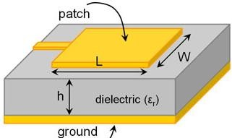

Figure.1.1 Structure of Microstrip antenna

Microstrip antennas can be of different like square, rectangular, circular, elliptical and also any continuous possible shape [12].

SUBSTRATES

The usage of substrate is principally needed in microstrip antennas for the mechanical support of the antenna. In order to support stability substrate should consist of a dielectric material which effects the electrical performance of the antenna and transmission line [23-24].
Table.1.1 Various substrates used for design of patch antenna

Name of the substrate | Relative permittivity
Diamond | 1
Teflon | 2.1
Taconic RF-35 | 3.5
Rogers RT/duroid 5880 | 2.2
Rogers RO4350 | 3.66
Epoxy Glass | 3.4

FR4 Epoxy | 4.4
Dielectric Substrate: FR-4 (high loss, low gain antenna, cheap, easy availability); low loss and low permittivity (RT Duroid 6002, PTFE, high gain antennas); portable n mobile (RO4730, high performance, low weight, low permittivity, low loss, low distortion); ceramic (Rogers RO 3200, low cost, GPS patch antenna) etc. Dielectrics are used for improved mechanical and electrical stability. They are utilized to decrease the size of the antenna (higher permittivity, lower size) and can assist with creating displacement current which produces time changing Magnetic Field (by Ampere's Law). This can thus deliver time differing Electric Field (by Faraday's law) and a propagating EM field is created. Thus, a substrate can improve antenna's radiation capacity.

FEEDING TECHNIQUES

Microstrip antenna can feed by variety of methods. Those methods are of two categories-contacting and non-contacting schemes. The foremost popular feeding techniques are microstrip line, co-axial, proximity coupling and aperture coupling [35-37].
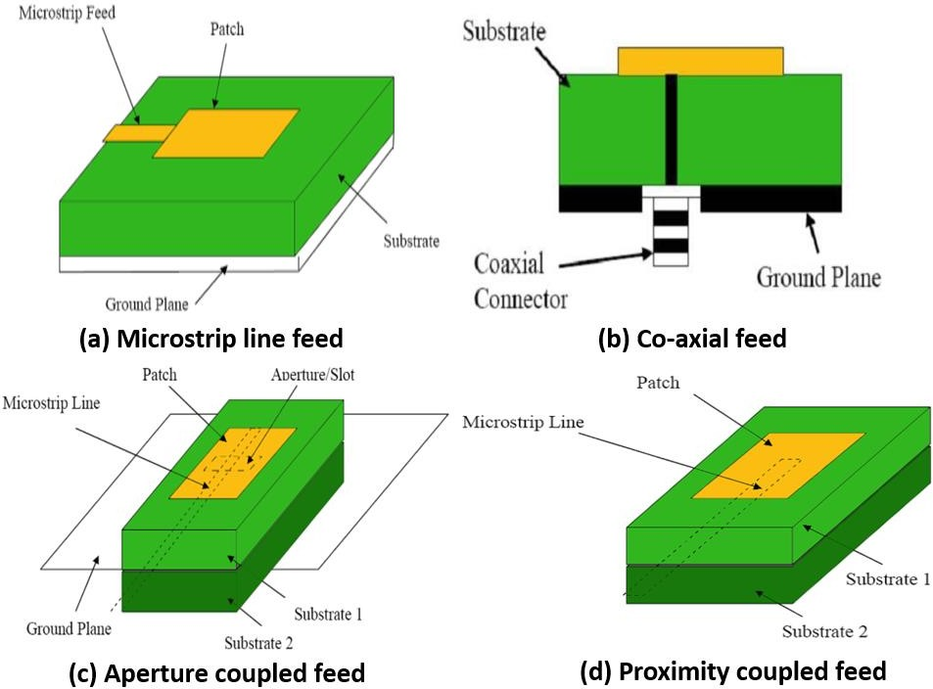

Figure.1.2 Different feeding techniques

Microstrip Line

In this feeding technique, a conducting strip is directly connected to the edge of the patch as shown in figure.1.2(a). This type of feed also called Offset Microstrip line feed (contacting scheme) [26]. The advantage is that the feed can be etched on the same substrate to provide a planar structure. It provides ease of fabrication, impedance matching.

Co-axial feed

the most common feeding technique used for microstrip antennas is Co- axial feed (or probe feed). An inner conductor of co-axial connector extends through the dielectric substrate and is soldered or attached to the radiating patch and the outer conductor is connected to the ground plane as shown in Figure.1.2(b). The advantage of probe feed is that the feed can be placed at any desired position to provide impedance matching.

Aperture coupling

Aperture coupled feed is an indirect method of feeding the patch (non- contacting scheme) shown in figure.1.2(c). It couples the patch antenna with microstrip line through an aperture and creates an electric filed in the aperture which induces surface currents on the patch. The disadvantage of this technique is that difficult to fabricate because of having multiple layers, also increases the thickness of the antenna.

Proximity coupling

This feeding technique also called as electro-magnetic coupling scheme. In this feeding, two substrate materials are used so that the feed line is given in between those two substrates and the patch is on top of the upper substrate material shown in figure.1.2(d). Here, also the thickness of antenna increases.

Table 1.2 Comparison of various feeding techniques

Characteristics | Co-axial feed | Aperture coupled feed | Proximity coupled feed | Microstrip line feed
Spurious feed radiation | More | Less | Minimum | More
Bandwidth | 2-5 % | 21% approx. | 13% approx. | 2-5 %
Ease of  fabrication | Drilling & Soldering needed | Alignment is required | Alignment is required | Easy
Reliability | Poor due to soldering | Good | Good | Better
Impedance matching | Easy | Easy | Easy | Easy

RADIATION MECHANISM
The main purpose of an antenna is power radiation or reception. The Antenna can be attached to the circuitry at the station through a transmission line [33-34]. The performance of an antenna depends upon the radiation mechanism of a transmission line.
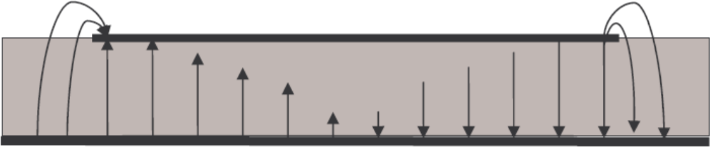
The radiation from an antenna occurs when the Electromagnetic field is generated by a source is transferred to an antenna equipment through the Transmission line and separated from the Antenna into free space.

Figure.1.3 Radiation mechanism
Radiating mechanism is of two types 1.single wire 2.two wire

- Single-wire: radiation in an antenna occurs if the wire is curved, discontinuous, bent and terminated and when the charge is oscillating in time-domain, it radiates even the wire is straight [42-44].
Different wire configurations for single wired antenna radiation are
  - Curved wire: helical antenna and loop antennas comes under this category these type of antennas are used for high frequency portable transceivers which are used in ultra-wide band communications.
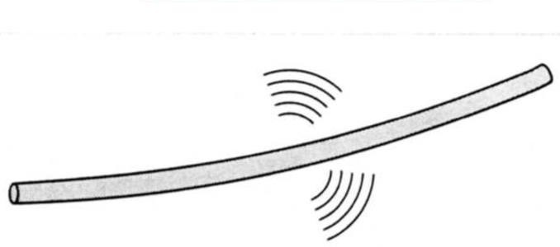

Figure.1.4 Curved wire
  - Bent wire: the radiation takes place more efficiently when the wire is bent, either it may be single end or at both the ends of the wire because the flow of transmitted energy tries to escape from the transmission line
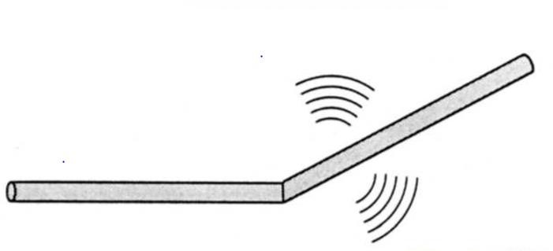

Figure.1.5 Bent wire

  - Discontinuous wire:
The flow of transmission of energy is very high when the wave is transmitting from one boundary to another, this discontinuity in the medium is called as discontinuous wire

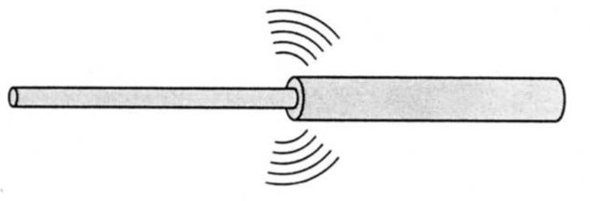

Figure.1.6 Discontinuous wire
  - Terminated wire: the perfect termination in an antenna occurs when the wire is properly terminated, this type of wired antennas can work even in noisy-environment without any tuners
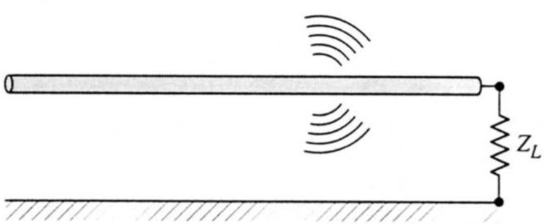

Figure.1.7 Terminated wire
- Two-wire:
Let us assume that a voltage source is connected to a two-conductor transmission line which is connected to an antenna. By introducing the voltage across the two-conductor line transmission produces a strong electric filed between the conductors [42]. Both linear and half dipole comes under this two-wire radiation mechanism
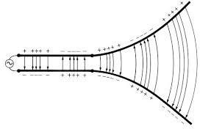

Figure 1.8 Two-wire Transmission line

SIMULATION TOOL USED

HFSS is a predominant full wave electromagnetic (EM) field test system for subjective three-dimensional volumetric detached gadget demonstrating that exploits the common place Microsoft Windows graphical UI [44]. It coordinates reproduction, portrayal, strong displaying, and mechanisation in an easy to learn condition where answers for your 3D EM issues are quickly and precise gotten. Ansoft-

HFSS uses the Limited Component Technique (FEM), versatile cross section, and magnificent illustrations to give you unmatched execution and knowledge to the majority of your 3D EM issues. Ansoft HFSS can be used to determine parameters, for example, S-Parameters, Resounding Recurrence, and Fields.
Typical uses include:
- Package Displaying – Flip-Chip, QFP, BGA
- PCB Load up Displaying – Power or Ground planes, Work Network Grounds, Back planes.
Silicon/GaAs-Winding Inductors, Transformers.
- Connectors – Cajole, XFP/SFP, Back plane, Advances.
- Waveguide – Channels, Resonators, Changes, Couplers.
- Filters – Pit Channels, Miniaturized scale strip, Dielectric.
- HFSS is an intelligent reproduction framework whose essential work component is a tetrahedron. This enables you to unravel any subjective 3D geometry, particularly those with complex bends and shapes, in a small amount of the time it would take utilizing different methods.
- The name HFSS represents High Recurrence Structure Test system. Ansys spearheaded the utilization of the Limited Component Strategy (FEM) for EM recreation by creating/executing advances, for example, digressive vector limited components, versatile cross section, and Versatile Lancozos - pade Breadth (ALPS). Today, HFSS keeps on coming out on top with advancements, for example, Modes to Hubs and Full-wave Zest.
- Ansys HFSS has advanced over a time of years with contribution from numerous clients and businesses. In industry, Ansys HFSS is the apparatus of decision for High profitability research, advancement, and virtual prototyping.

APPLICATIONS OF HFSS
HFSS is utilized in different field to mimic and get required examples. Some of them are
      - Antennas
      - Microwave advances
      - Waveguide segments
      - RF channels
      - Three-dimensional discontinuities
      - Passive circuit components

SYSTEM REQUIREMENTS TO RUN HFSS
ANSYS, CFX, Familiar, AUTODYN, HFSS, and MAXWELL are
altogether bolstered on Windows 7 64-bit. This stage gives the investigation network incredible figuring limit while conveyed at item estimating. A multicore 64-bit processor framework can address a lot of Smash and permit huge document sizes. A recommended examination framework might be something like:
- Double Six Center or Eight Center Processors
- Windows 7 64bit
- 1 GB (or higher) illustrations card (DRD has had great involvement
with NVIDIA cards).
- 12-48 GB of Smash
- DVD R/W Drive

FABRICATION METHODS

Antennas can be fabricated using two methods. They are (1) Photolithography process (2) PCB prototype machine.

PHOTOLITHOGRAPHY PROCESS

The format is made utilizing CAD devices and print out of the negative veil of the plan is made on a straightforward or a semi- transparent sheet. To expel impurities from the metallization of the substrate, it is cleaned with acetone. A blend of photoresist and more slender in the proportion 1:1 is made and covered over the substrate. In

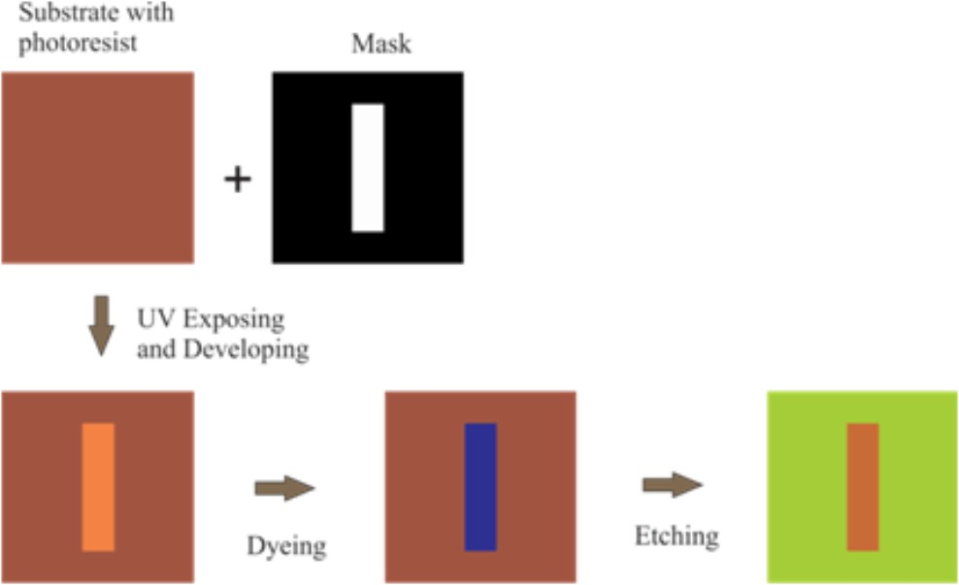
the wake of drying, the veil is put over the substrate and is presented to the UV light. The uncovered substrate is then plunged in the developer solution for solidifying the photoresist in the uncovered part. The covered segment must be expelled. The substrate is plunged in the dye in order to show signs of improvement perceivability of the uncovered photoresist and washed utilizing water. The undesirable copper portions are evacuated utilizing the etching procedure utilizing Ferric chloride. FeCl3 disintegrates the unexposed copper covering. Photolithography process is shown in figure.1.9.

Figure.1.9 Photolithography process

PCB Prototype Modelling

Hardware implementation of designed antenna is done using PCB Prototype machine which is the process of removing the areas of copper from a sheet of substrate material i.e., printed circuit board to recreate the structures according to the designed antenna from HFSS simulation software. PCB milling is a non-chemical process and it can be done in a lab environment without exposure to hazardous chemicals.

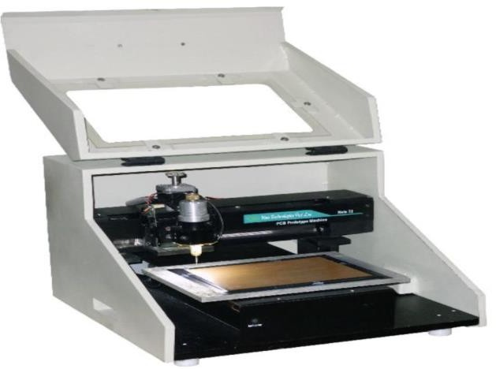

Figure.1.10 PCB Prototype machine

AMENITIES FOR ANTENNA MEASUREMENT

Testing of real antennas are measured using anechoic chamber and vector network analyzer and the importance of these instruments are described below.

ANECHOIC CHAMBER
An anechoic chamber is a room which absorbs all the reflections of either electromagnetic waves or sound. In-addition they are confined from waves entering from their environment. This means that a human can hear only direct sounds, in effect simulating being inside a large room. For testing antennas, radars RF anechoic chamber is used in which interior surfaces are covered with radiation absorbent material instead of acoustically absorbent material shown in figure.1.11. RF anechoic chambers are used for measuring of antenna radiation patterns, electromagnetic interference.

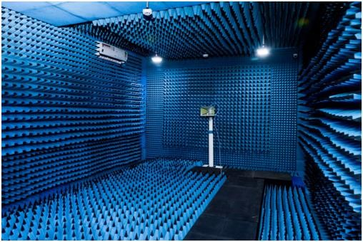

Figure.1.11 Anechoic chamber

VECTOR NETWORK ANALYZER
Vector network analyzers are used for testing and verifying component specifications and design simulations respectively for making sure that their elements work properly. A Vector Network Analyzer contains both a source used for generating a stimulus signal and a set of receivers which are used for determining the changes in the stimulus caused by device-under-test or DUT. A VNA is a test system that enables the RF performance of microwave devices and radio frequency microwave devices to be analyzed in terms of network scattering parameter, or S- parameters shown in figure.1.12.
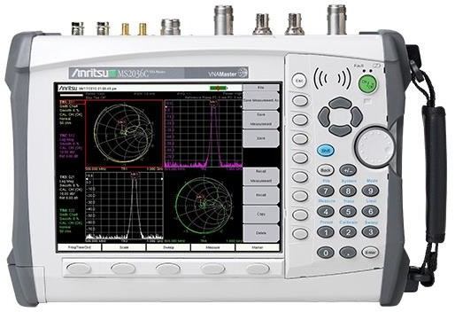

Figure.1.12 Vector Network Analyzer

DEFECTED GROUND STRUCTURE

The one of the limitations of microstrip antenna is lesser bandwidth which can be increased by introducing defected ground structure, altering the shape of patch, low dielectric substrate. In DGS, the defects in the ground plane can be either periodic or aperiodic, thus the current distribution in ground plane is disturbed and changes the current distribution and enhance the bandwidth of the microstrip patch antenna [3-5]. In DGS antenna, we can alter the ground plane and patch by using various shapes like E-shape, H-shape, T-shape, dumbbell, semi- dumbbell.

RESEARCH MOTIVATION

The growth of wireless communication and information transfer is in demand for various applications. They created the need for advancements of antenna designs which acts as an important part of any wireless system. There are different types of antennas, one of those antennas that is required for wireless communication is microstrip antennas. These antennas have different configurations and presently used as an active field in the research and development of antennas. Due to advantages of microstrip antennas, there are wide range of applications in wireless communications. Thus, using single antenna we can make use of wideband or multiband applications.

OBJECTIVE OF THE RESEARCH

The objective of our project is to design and simulate a novel compact ultra wideband microstrip patch antenna using defected ground structure. In the design of microstrip patch antenna we can the drawback of narrow bandwidth by introducing defects on the ground plane. Thus, we can obtain higher data rate and greater bandwidth using DGS. Investigating the effects of including different defected ground structures. In our proposed design circular slots are introduced in the patch and the ground.

ORGANIZATION OF THE THESIS

The Thesis is organized into 7 chapters

Chapter 1: Discuss about the introduction to microstrip antennas, mainly about feeding techniques, HFSS simulation software and system requirements of it. Motivation towards the present work is also discussed.
Chapter 2: Antennas in literature for different applications are reviewed. Also, antennas with different Defected ground structures are surveyed for both wideband and multiband frequencies.
Chapter 3: Describes the importance of Defected ground structure and its applications and discussed about basic transmission characteristics of a DGS unit.
Chapter 4: Theoretical analysis of the proposed antenna is discussed and also design specifications are mentioned. The design flow of the proposed antenna is discussed.
Chapter 5: Describes how proposed antenna is designed using HFSS simulation software and shows step by step procedure to design a microstrip patch antenna.
Chapter 6: Gives a detailed analysis of the proposed antenna performance and final results are shown. The characteristics of the proposed antenna are observed and plotted.
Chapter 7: Concludes the highlights of our work in the thesis and future scope of the antenna are discussed.

CHAPTER 2 LITERATURE SURVEY
In this literature survey, how a microstrip antenna is designed is observed through different research papers. The following survey describes the step-by-step analysis of design of a microstrip patch antenna. The limitations of microstrip antenna are less data transmission capacity and low gain. These limitations are improved by using various shapes of patch antenna, defected ground structure etc.

MICROSTRIP PATCH ANTENNAS

Houda Werfilli et al designed a rectangular microstrip patch antenna [12] whose reflection coefficient is less than -10dB, operates at 3.1-5.1GHz, in which they explained about different feeding techniques but works only for few applications.
Gazala Pravin et al proposed a low cost microstrip patch antenna array for wireless communications [11] which is designed for high-speed wireless local area networks, in which a good VSWR value was observed but this antenna operates only at 5GHz frequency band.

MULTIBAND MICROSTRIP PATCH ANTENNAS

Abdolmehdi Dadgarpour et al [1]; Slotted ground plane is used to increase the resonant frequencies. This antenna can support applications like PCS, WLAN, Bluetooth, WiMAX, HIPERLAN. When -6 dB is used as reference this antenna covers DCS band (1.71-1.88 GHz). Radiation efficiency is more than 80% in all surveyed bands.
Radouane KARLI et al designed a multiband microstrip patch antenna for wireless communications [27]. In this paper the size of the antenna is 45mm ×70mm. This antenna supports wireless applications like GSM cellular phone system, Wi-Fi, WLAN, Bluetooth.
Y.F Cao et al [39]; The GPS systems use circularly polarized signal with a frequency band from 1570 MHz to 1590 MHz but most wireless

devices uses linearly polarized antenna to receive GPS signal. This will lead to -3 dB power loss which is acceptable by wireless device designers. The size of the ground plane affects the antenna performance.
Vyshnavi Das S K et al designed a Multiband Microstrip Patch Antenna for IOT Applications [37]. In this paper the size of the antenna is 130mm X 90mm. The antenna has the resonant frequencies of 1.54GHz, 2.73GHz, 3.63GHz, 4GHz, 4.61 GHz, 5.32 GHz, and 6.44 GHz.
S. A. Shelke et al proposed a Dual-Band Microstrip Patch Antenna for Wireless Applications [30], which operates at two frequencies of 5.10-
5.55 and 5.725-6.25 GHz but in this paper the size of the antenna is very large and also having very less band width.
Youssef Rhazi et al designed a Multi-band Microstrip Patch Antenna for Wireless Communication [40]. In this paper the size of the antenna is 22mm×30mm. This antenna supports 3 resonant frequencies 4.1- 4.3 GHz, 5.21-5.43 GHz and 6.55-7.25 GHz which are in omni- directional pattern and the remaining frequencies 7.02-7.15 GHz, 9.07-
9.15 GHz and 10.02- 10.5 GHz are in directional pattern.

WIDEBAND MICROSTRIP ANTENNAS

S. Taha Imeci et al designed a Wideband Microstrip Patch Antenna at 7 GHz [32]. In this paper an edge-fed microstrip antenna was designed which operates at 7.1Ghz and having a gain of 4.5dB. this antenna operates only at one frequency and having a return loss of 10%.
Deependra Khandelwal et Al proposed a Multi-Frequency Wideband Microstrip Patch Antenna for Wlan/Hiperlan/ Satellite Applications [8]. In this paper a rectangular microstrip patch antenna which is having a multi frequency bandwidth of 385MHz, 517MHz and 1111MHz was proposed which are applicable only for WLAN, HIPERLAN and satellite communication systems.
Bharatendra singh niboriya et al designed a S-shape Wideband Microstrip patch Antenna with Enhanced gain and Bandwidth for

Wireless Communications [6]. In this paper the proposed antenna is applicable for S-Band and C-Band but having a very less impedance bandwidth of 67.23%.
Vivek Singh Rathor et al designed a swastika shaped wideband microstrip patch antenna for GSM/WLAN Application [36], which operates at 1.6GHz- 2.5GHz and can be used for GSM and WLAN Applications having a good impedance bandwidth but operates at very low frequencies.
M. Gunavathi et al designed a miniaturized UWB microstrip patch antenna for wireless communication [19]. In this paper, an E-shaped microstrip patch antenna is designed to support UWB frequency ranges and it supports wireless applications like Wi-Fi, WLAN, WiMAX and satellite applications. It operates at six resonant frequencies.
S. Sri Harsha et al designed a microstrip patch antenna using UWB for wireless communication devices [33]. In this paper a monopole antenna which is a having low profile and low volume was constructed and operates at very low frequencies.
Karishma D et al designed a wideband Monopole Square microstrip patch antenna [17]. In this paper the antenna operates from 2.47- 9.28GHz with an impedance bandwidth of 117%. Here, less gain is achieved i.e, gain=2.36dB.
MHD Amen Summakieh et al propose a Single Wideband Microstrip Patch Antenna for 5G Wireless Communication Application [20]. In this paper they discussed about an antenna which operates at 6GHz frequency which is having less size, but bandwidth of 500MHz only.

WIDEBAND MICROSTRIP PATCH ANTENNAS USING DEFECTED GROUND STRUCTURE
Jing Pei et al [15]; Radiating element consists of circular ring and Y-shaped like strip. The width and length of 50ohm microstrip feed is 2.4 mm and 12.06 mm. Cambered ground plane is used at the back side of ground plane. Isosceles triangle is etched in the ground plane under the microstrip feed for impedance matching. The gap between the circular ring and the arc shaped strip affects the impedance performance and resonant frequencies of the antenna. The defected ground-plane acts as a filter for removing unnecessary frequencies. After adding Y-shaped strip the antenna resonates at dual band such as 2.58 GHz, 3.58 GHz. The radiation pattern in the H-plane is omnidirectional whereas E-plane is monopole.
Wen-Chung Liu et al [39]; Slots are used in the ground plane to excite the resonant modes and improve the impedance matching. The obtained bandwidth covers the WLAN standards (2.4/5.2/5.8 GHz) and WiMAX standard (3.5/5.5 GHz). Without using defected ground plane antenna is not matched. With the use of L-shaped strips improves impedance matching and excite additional resonance. Radiation pattern is nearly omnidirectional. With the increase in operating band, efficiency increases but the directivity decreases because current in lower frequency is more in-phase and concentrated in the same direction for high directivity.
Praveen nartam et al designed an ultra-wide band antenna using defected ground structure [26]. In this paper, Ultra-wideband (UWB) antenna with two blend edges at the rear end of the microstrip patch and microstrip feedline at the fore side is presented. The backside has partial ground plane with triangular-shaped slots. It operates at frequencies between 3.58-9.93GHz with a bandwidth of 6.35GHz
Rahul suvalka et al designed a planner microstrip antenna for wireless and lower UWB Applications using DGS [28]. The operating frequency of this antenna Ranging from 3.4-5.9GHz with constant gain

and this is useful for Lower Ultra Wideband applications, WIFI, WLAN and Wi-Max Applications. This antenna produces an impedance bandwidth of 52%.
Neha Tanzeem Sagar et al designed an Ultra Wideband Circular Ring antenna with defected ground structure [22]. In this paper a round patch antenna is designed with rectangular DGS structure and a slot is inserted in circular-patch to enhance the bandwidth. Thus, it covers the frequency range of 2.4GHz-10.4GHz below -10db.
Bhanu Priya kumawat et al designed a square shaped slotted multiband microstrip patch antenna using defected ground structure [4]. In this paper the size of antenna is 50mmx50mm. A simple H shape DGS geometry is used for multiband and good radiation results. H-DGS have a good characteristic of passband and stopband. It operates at three resonant frequencies 2.3GHz, 5.3GHz and 6.7GHz.
Amiya B. Sahoo et al designed a multiband rectangular patch antenna using defected ground structure [2]. In this paper the size of the antenna is 30mmx32mm. The proposed radiating patch is circular in shape and the ground plane is defected by two circular slots placed symmetrically on the y-axis. This antenna operates at three resonant frequencies.
D. D. Ahire et al proposed a defective ground corner rounded UWB microstrip patch antenna for Bio-Medical Applications [7], this paper discussed about defected ground structure which improves the bandwidth and operates at 3.1-12.72GHz and having a good VSWR value but the size of the antenna is large.
S. Sivagnanam et al designed a multi-slot rectangular microstrip patch antenna with defected ground structure for wireless applications [31]. In this paper the antenna operates from 3.5-11.7GHz. Impedance matching and bandwidth of the proposed antenna are effected by the radius of circular slot and position of rectangular slot on the ground plane.

P. Rakesh kumar et al designed a wideband hexagonal ring antenna with defected ground structure [25]. In this paper the antenna operates from 2.4 to9.8GHz with an impedance of 112%. But the size of the antenna is large.
Jigar M et al designed a Defected Ground Structure Multiband Microstrip Patch Antenna using Complementary Split Ring Resonator [14]. In this paper the size of the antenna is 50mm×50mm. The proposed design is having seven bands in the frequency range of 1–5 GHz.
P. Rakesh Kumar et al designed a novel compact wideband Hexagonal circular-ring patch antenna with Defected ground structure (DGS) [24] having dimensions of 50mm x 42mm x 1.6mm using commonly available FR-4 Substrate with permittivity of εr=4.4. The patch antenna with DGS works at frequency range of 2.5 GHz to 10.68 GHz with impedance bandwidth of 126.15% and support different wireless applications like WiFi, WiMax and X-band.

CHAPTER 3 DEFECTED GROUND STRUCTURE

INTRODUCTION TO DGS

Generally, microstrip antennas have some drawbacks, that is, only one resonant frequency, low impedance data transfer capacity, size is large, low gain and some of the issues in polarization. There are different methods which have been accounted for upgrading the parameters of microstrip antennas i.e., usage of stacked antenna method, various feeding methods, Frequency Selective Surfaces (FSS), Electro-magnetic Band Gap (EBG), Metamaterial, Photonic Band Gap (PBG) etc. Microwave devices with DGS has gained demand among all the methods announced for improving the variables due to its plain organizational design. Engraved slots or defects on the ground-plane of microstrip circuits are mentioned as Defected Ground Structure. One or more deformities on the ground plane is regarded as DGS. At first, DGS is described for filters under the microstrip feedline [18]. DGS is used underneath the microstrip line to obtain bandstop characteristics and to putdown mutual coupling and higher mode harmonics. After successful execution of DGS in the field of filters, these days DGS is in request broadly for various applications.

BASIC STRUCTURE AND TRANSMISSION CHARACTERISTICS

The proposed DGS is single dumbbell shaped defect. It is composed of two rectangular defected areas, gaps and a narrow connecting slot wide-etched area in ground plane as shown in figure.3.1(a). The S- parameters for this DGS is shown in figure.3.1(b). DGSs have advantages like circuit area becomes small without any periodic structures that is only few DGS elements have typical properties as the periodic structure like the stopband characteristics, the simulated S-parameters for dumbbell DGS unit can be matched to the one-pole Butterworth type lowpass response. While comparing DGS with PBG (Photonic Band Gap) it can be easily designed [19-21], implemented and it has higher

precision with normal defect structures. Thus, DGSs has their prominent role in applications of microwave circuits.
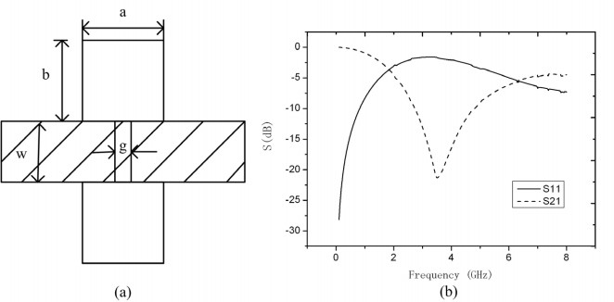

Figure.3.1 Basic DGS unit (a) dumbbell DGS (b) S-parameters graph for dumbbell DGS unit
The equivalent circuit of a DGS element is shown in figure.3.2. The R, L, C values are calculated by the dimensions and location relative to the through transmission line. The dimensions are calculated using center frequency and bandwidth Q and the structure can be simply set to the required center frequency. The reactance of equivalent circuit is given as
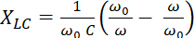;
Where w is the angular resonant frequency and the reactance is given as where is the normalized angular frequency, is input and output port impedance, and is the prototype element
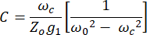
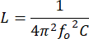

Where fo = Resonant Frequency for DGS

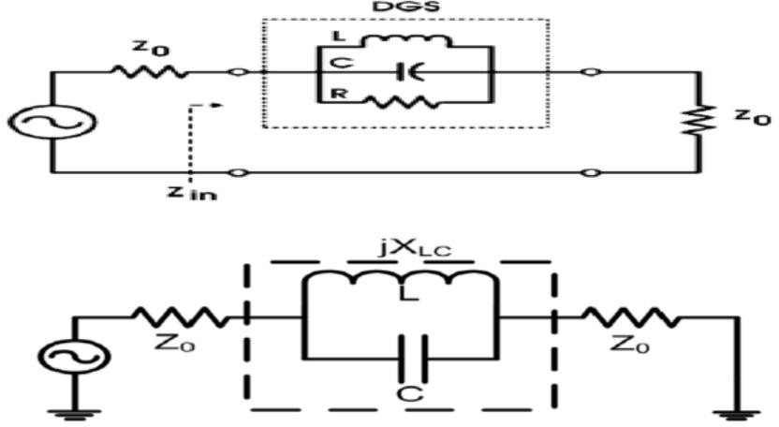

Figure.3.2 Equivalent circuit of DGS element

A variety of slot geometries are existed that are used in making defects on the ground plane of microstrip patch antenna shown in figure.3.3. Some of the structures are complex DGSs and are used to improve the performance of the antenna.
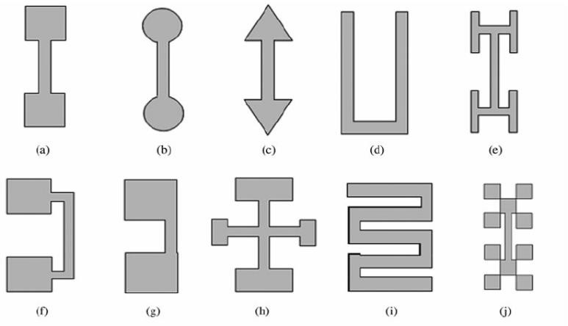

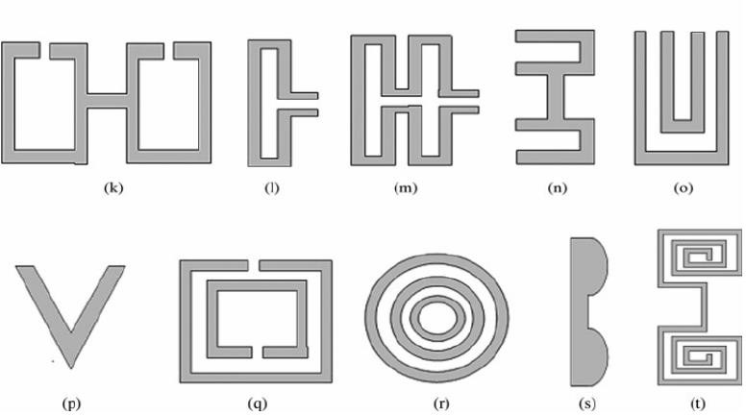

Figure.3.3 Various DGS shapes: a) dumbbell shaped, b) round headed dumbbell, c) arrow-head dumbbell, d) U-shaped, e) H- shaped, f) squared head connected with U-slots, g) square slot connected with lean slot at edge, h) cross-shaped, i) inter-digital, j) unsystematic, k) open loop dumbbell l) L-shaped, m) meander lines, n) U-head dumbbell, o) double equilateral U, p) V-shaped, q) split-ring resonators, r) concentric ring-shaped, s) half-circle, and
t) spiral-shaped.

APPLICATIONS OF DGS

There are wide applications in active and passive devices useful for compact design. As each DGS has its own particular characteristics depending on the shape or geometry, such circuit functionalities as separating the unnecessary signals and regulating higher order harmonics can be simply accomplished by placing necessary DGS design or shape. It corresponds to required circuit operations without increasing complexity in circuits.

DELAY LINES

Placements of DGS along a transmission line present changes in the spread of the wave along the line. The DGS components don't

influence the odd mode transmission, however eases back the even mode, which must spread around the edges of the DGS opening.

ANTENNAS

The sifting qualities of DGS can be applied to radio wires, decreasing common coupling between receiving wire cluster components, and diminishing undesirable reactions (like channels). This is the most well-known use of DGS for radio wires, as it can diminish side projections in staged exhibit, improve the presentation of couplers and force dividers, and decrease the reaction to out of band-signals for both transmit and get. A variety of DGs components can be organized on a level surface and lit up by a feed radio wire, much like an explanatory reflector reception apparatus. Every component re-emanates the energizing sign; however, a stage move can be incorporated with the structure to address for the separation of every component from the feed. The re-emanating components present extra misfortune, however the accommodation of a level structure factor is amazingly appealing for transportable hardware or applications where a position of safety is basic.

CONCLUSION

The impedance bandwidth is improved by considering the DGS in the design of the antenna. The advantage of using DGS are bandwidth enhancement, size reduction and frequency shifting. In the next chapter theoretical analysis and design specifications are discussed.

CHAPTER 4 THEORETICAL ANALYSIS

PROPOSED DESIGN

A rectangular patch antenna is designed by the arrangement of partial slotted ground structure. Rectangular patch is created by inserting a rectangle having dimensions 14.5x15mm2. The rectangular patch is modified by introducing circular slot in the patch having radius R1=1.5mm after that by making a defect at each corner of patch in the shape of circle with radius R2=2.95mm [6-7]. It is fabricated on FR-4 substrate with dielectric constant ℇr=4.4. The dimensions of the antenna are Length=35mm and Width=30mm and Height=1.6mm respectively. On the back side of the substrate a defected ground plane is introduced to achieve high bandwidth [9-18]. The feeding method used to excite the antenna is microstrip feed line.
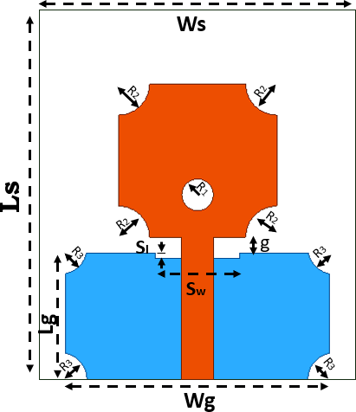

Figure.4.1 Design of rectangular patch antenna with DGS TABLE 4.1 Dimensions of the proposed antenna
Parameter | Notation | Dimension (mm)
Length of the substrate | Ls | 30

Width of the substrate | Ws | 35
Ground Length | Lg | 12
Ground Width | Wg | 25
Feed line Length | Lf | 13.5
Feed line Width | Wf | 3
Radius of circular ring | R1 | 1.5
Patch Length | Lp | 14.5
Patch Width | Wp | 15
Radius of Circular slots in Patch | R2 | 2.95
Gap | g | 1.5
Radius of Circular slots in Ground | R3 | 2.55
Rectangular Slot in Ground | Sl | 8
 | Sw | 1

DESIGN SPECIFICATIONS

The three essential parameters for the design of a rectangular Microstrip Patch Antenna is

FREQUENCY OF OPERATION (F)

The resonant frequency of the antenna must be chosen properly. The Personal Communication system (PCS) utilizes the frequency range from 1850-1990 MHz’s. Hence the antenna structured must be able to operate in this frequency range. For our design 3 GHz resonant frequency is selected.

DIELECTRIC CONSTANT OF THE SUBSTRATE (Ε)

For our design FR4 EPOXY dielectric material is selected which is having dielectric constant of 4.4. To reduce the dimensions of the antenna A

substrate with a high dielectric constant is selected. Here, FR indicates Fire Retardant and number 4 indicates glass epoxy resin.

HEIGHT OF DIELECTRIC SUBSTRATE (H)

For the micro strip patch antenna to be used in cellular mobiles, it is important that the antenna should not bulky in size. Hence, the height of the dielectric substrate is selected as 1.6 mm.

Calculation of the width ‘W’
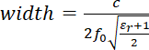

- Calculation of the Effective Dielectric Constant
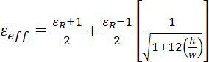

Calculation of Length
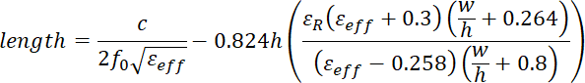

Where fo= Resonant frequncy, h= thickness of substrate, ℇR= Relative permittivity.

Return Loss

Return loss is a figure that means the proportion of radio waves appearing at the input of the antenna that are eliminated as a ratio against those signals that are taken. For example, a reception apparatus. In the system that the power given to the antenna under-test (AUT) is P (in) and the power returned back to the input port is P(ref), the level of difference between the occurrence and returned power in the travelling waves is given by the proportion Pin/Pref. If this level results higher then, the better the impedance matching is obtained.
Expressed in dB, return loss is defined

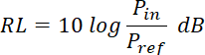

Which is a positive quantity if ref in P < Pi. Also defined in another way, RL is the difference in decibels between the power transferred towards the AUT and the power reflected. It is a positive non-dissipative term representing the decrease in strength of the reflected wave in comparison with the incident one. This is the situation for a passive AUT. A negative return loss is possible with active devices. Expressing the power in terms of voltage (similar to field strength) in a transmission line (assuming a passive AUT), then above equation becomes
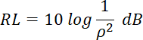

Where ρ is the reflection coefficient at the input of the antenna under test AUT. That is, return loss is the negative of the reflection coefficient expressed in terms of decibels. In terms of the voltage standing wave ratio (VSWR) then

The design flow of proposed antenna is shown in Figure.4.2
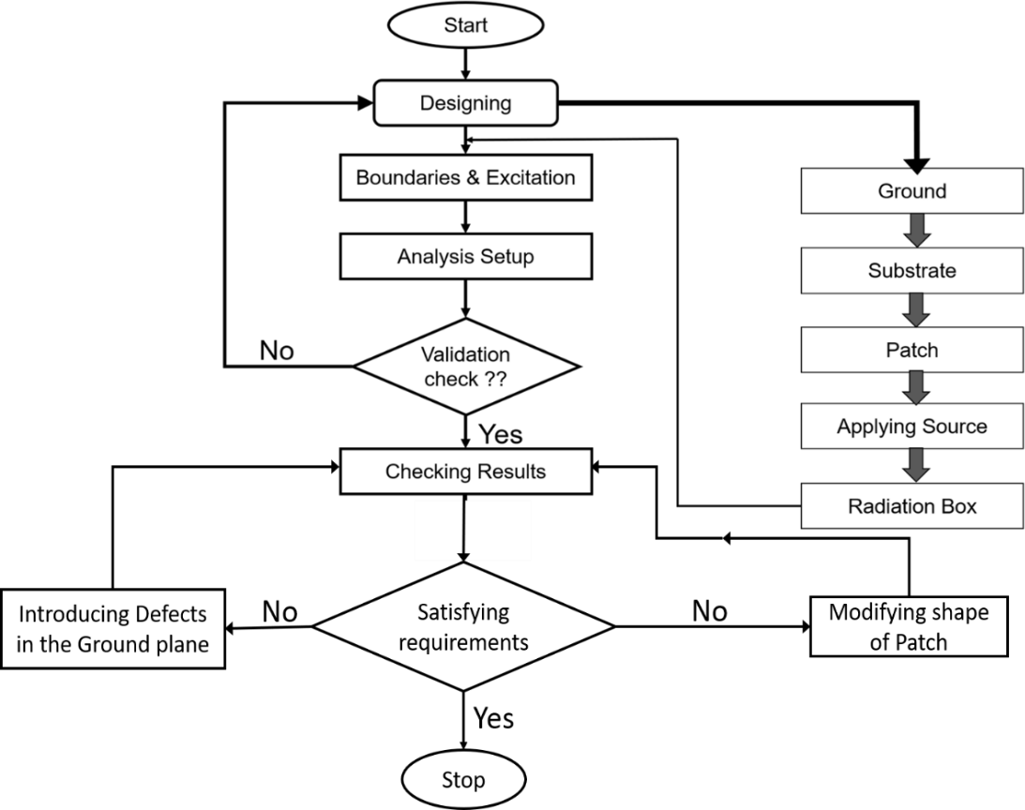

Figure.4.2 Design flow of Proposed antenna

The above figure describes the design flow of the proposed antenna. Initially, HFSS design environment is created. However, we know that microstrip antenna consists of 3 layers. They are ground, substrate and patch. First the ground plane is drawn using rectangle shape tool. The ground and the patch are two dimensional. Substrate layer is created by using box as it is having thickness of 1.6mm. Patch is also drawn using rectangle tool and dimensions are given as per the Table.4.1. Now, the input to the microstrip antenna can be given by using offset feeding technique and it is also drawn using rectangle shape. Since the ground and patch are conducting materials, we assign boundary as Perfect E (copper material) and substrate is taken as FR4 epoxy material. Excitation is given through lumped ports. In this design as we are dealing with radio waves, we need to simulate the results in a closed chamber. Thus, after completion of design of antenna structure we go for validation check and then checking results whether the results obtained are satisfied with our requirements. If not, further we go for either modifying shape of patch or introducing defected ground structure. After getting optimized results we stop the process.

CHAPTER 5

DESIGN OF MICRO STRIP PATCH USING HFSS

OUTLINE OF A PATCH ANTENNA
The objective of this section is to show how to create, simulate and analyze a microstrip patch antenna resonating at frequency of 3.5 GHz as shown in fig 5.1
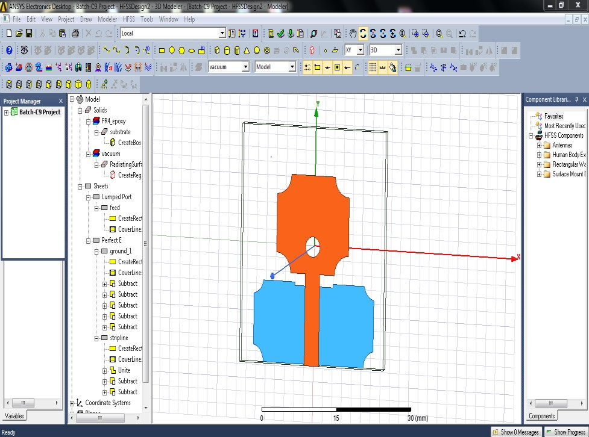

Figure.5.1(a) Original Design of Antenna Top View
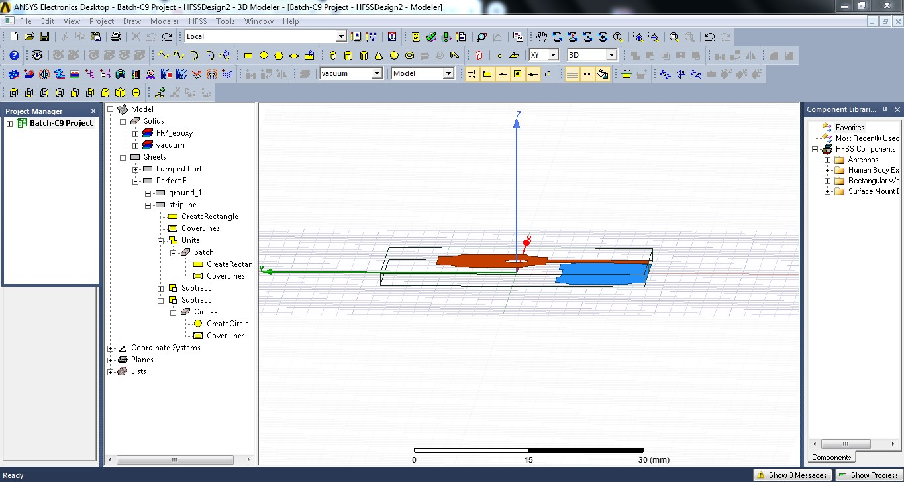

Figure 5.1(b) Side view

To set the solution type:
- Select the menu item HFSS > Solution Type
- Solution Type Window
- Choose Driven Model
- 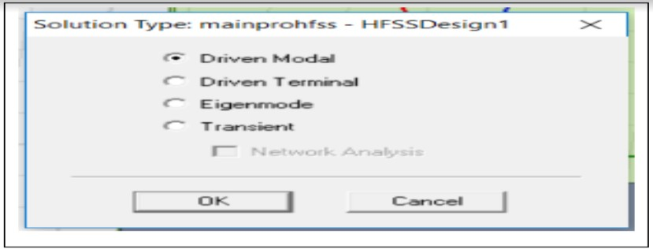Click the OK button

Figure.5.2 Solution Type Selections
Set Model Units To set the units:
    - Select the menu item 3D Modeler > Units
    - Set Model Units:
    - Select Units: mm
    - Click the OK button To set the default material:
    - Using the 3D Modeler Materials toolbar, choose Select
    - Select Definition Window:
    - Type FR4 epoxy in the Search by Name field; Click the OK button
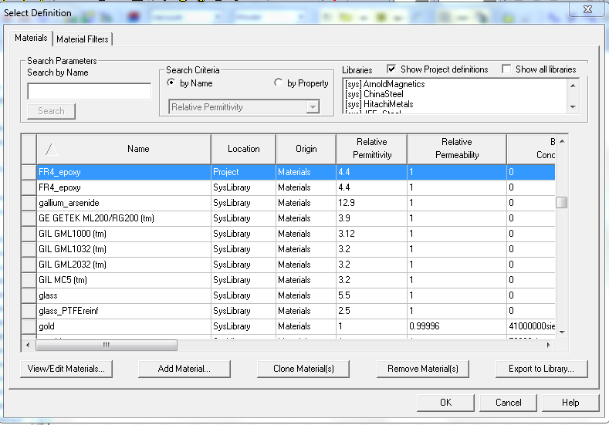

Figure.5.3 Choose of default value

DRAWING A SUBSTRATE

To draw the Substrate, click on the toolbar. Then draw a box by filling the following data as shown below.
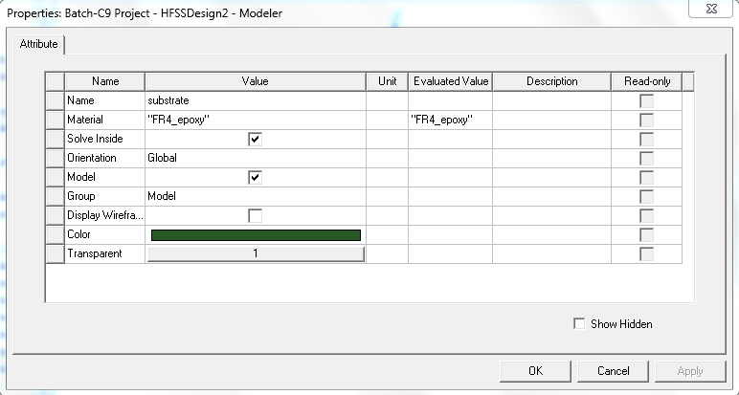

Figure.5.4(a) Drawing Of substrate
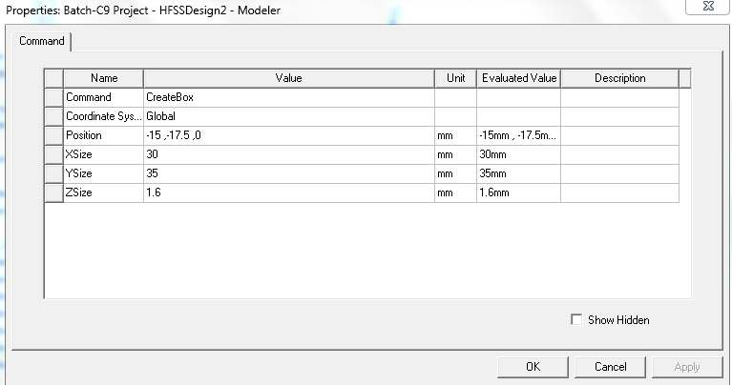

Figure.5.4(b) Dimensions Of substrate

PATCH

To draw the rectangular Patch, click on the toolbar. Then draw a box tool by giving the following data as shown below.

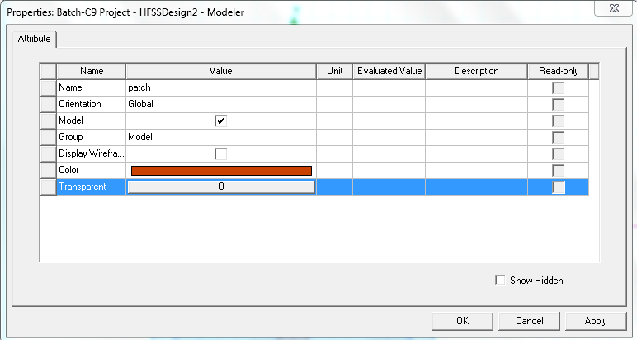

Figure 5.5 Patch modelling
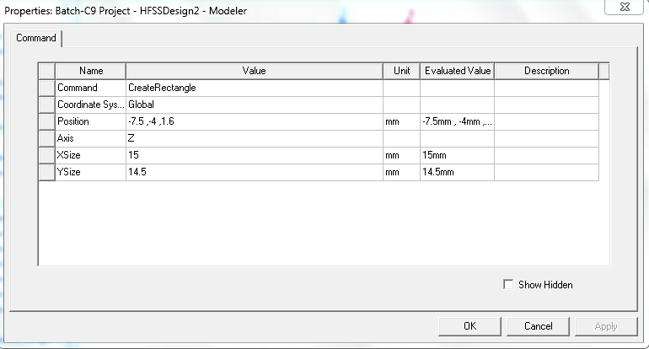

Figure.5.6 Patch dimensions modelling

As we all know that the Patch and Feed line are considered to be single object and same material. So, we have to unite them. Click on both objects that you need to unite that is Patch and Feedline in the history tree. Click on one and hold the CTRL key and click on the other. Right Click Edit > Boolean > Unite. Thus, these 2 objects are united.

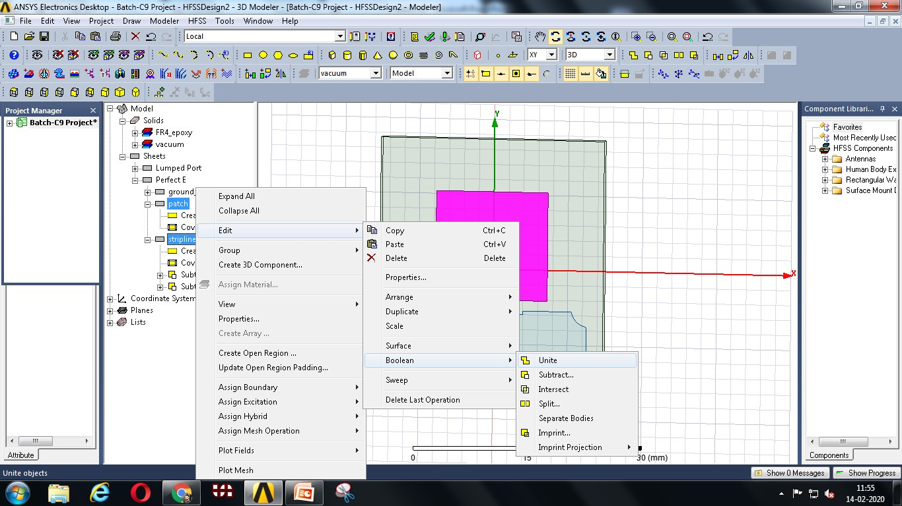

Figure.5.7 Uniting of Objects

GROUND PLANE

To draw the Ground Plane, click on the toolbar. Then draw a box by giving the following data as shown below.
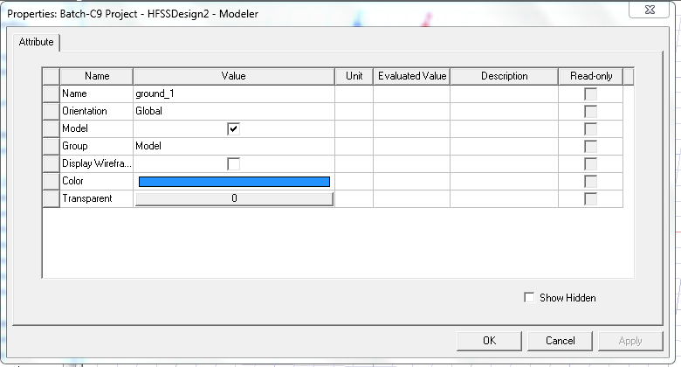

Figure.5.8 Ground formation

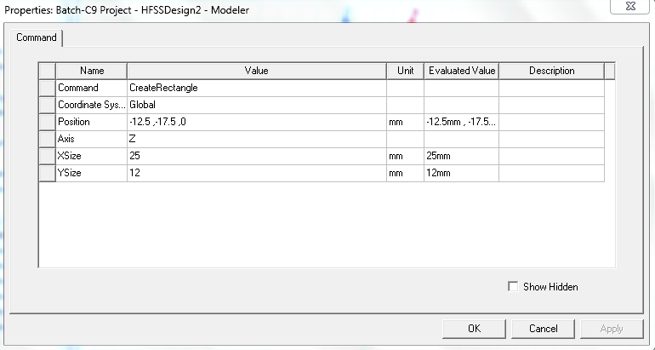

Figure.5.8.1 Ground formation with dimensions

MICROSTRIP FEED LINE

To draw the Microstrip Feedline, click on the toolbar. Then draw a plane in XY axis with corresponding dimensions as shown in the following figure.
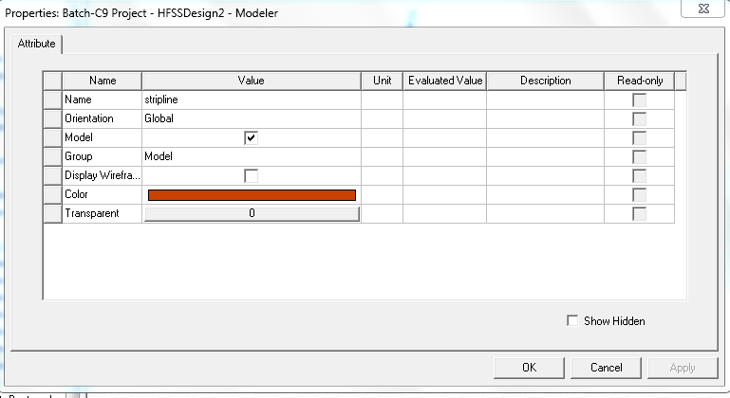

Figure.5.9 Feed line formation

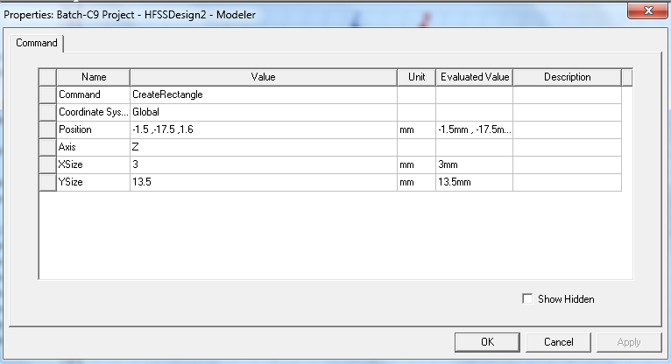

Figure.5.10 Feed line dimensions

ASSIGN EXCITATION
In Microstrip feed line the conducting strip is connected to edge of the patch. Antennas are excited through Lumped port in this feeding technique. To draw the input port, click on the toolbar. Then draw a plane as per the dimensions by giving the following data as shown below.
Choose the object Port from history-tree, right-click and assign excitation. In our case, it is lumped port. Click lumped port, name it as your preference.
To assign Lumped-port excitation
Select the menu item HFSS > Excitations > Assign > Lumped port Lumped port: General
Name: p1
Click the Next button

ANALYSIS SETUP
After design is completed it is ready to run. Now, we have to give analysis setup. To create an analysis setup, select the menu item

HFSS > Analysis-Setup > Add.

SOLUTION SETUP
In the Solution-Setup window, click the general tab, Solution frequency is 5 GHz, Maximum Number of Passes are 19 and loss tangent per Pass is 0.02.

ADD FREQUENCY SWEEP
To add a frequency sweep, select the menu item as
HFSS > Analysis Setup > Add Sweep. Select Solution Setup: Setup-1. Click OK button. Then Edit Sweep Window. Sweep Type: Fast, Frequency Setup Type: Linear Count, start: 1 GHz, Stop: 16 GHz, Count: 1000. Click OK button.

MODEL VALIDATION
To validate the designed model, select the menu HFSS > Validation Check. Click the Close button. If any errors or warnings messages occurred go to the Message Manager.
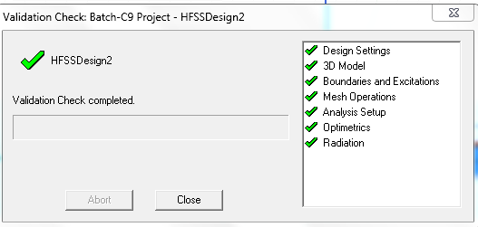

Figure.5.11 Validations checked

ANALYZE
To run the simulation, click the green exclamation point in the toolbar (located next to the green validation check mark). This will run all simulation setups associated with the current design. Alternatively, you may right-click on an individual solution setup (such as in the Project Manager and select 'Analyze').

CONCLUSION
In this chapter the complete design of the microstrip patch antenna using HFSS is discussed and mentioned about analysis setup, solution setup. In next chapter, the parametric analysis is done to analyze the characteristics of proposed antenna and experimental results are observed.

CHAPTER 6 EXPERIMENTAL RESULTS
  - ANTENNA DESIGN
The recursive process of designing the proposed antenna is carried out by changing iteration-1 to iteration-3 to obtain high impedance bandwidth

Antenna design with square patch (Iteration-1)

Initially, a square patch antenna with dimensions of 14.5 x 15 mm2 is designed. This antenna operates at frequency range 9.1-9.7GHz with impedance bandwidth of 6.38%.

Figure 6.1 Iteration-1
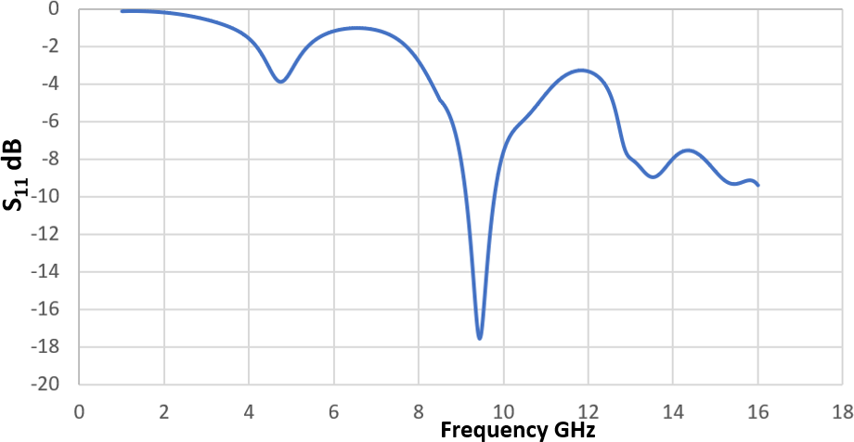
Figure.6.2 Return loss for Iteration-1

Antenna design with modified patch (Iteration-2)
Further, square patch antenna is modified by introducing circular slots at each corner of the patch having radius of 2.95mm and a circular slot at the center of patch with radius 1.5mm shown in figure.6.3.



Figure.6.3 Iteration-2
This antenna operates at frequency range 8.4-9.8 GHz with an impedance bandwidth of 16% shown in figure.6.4.
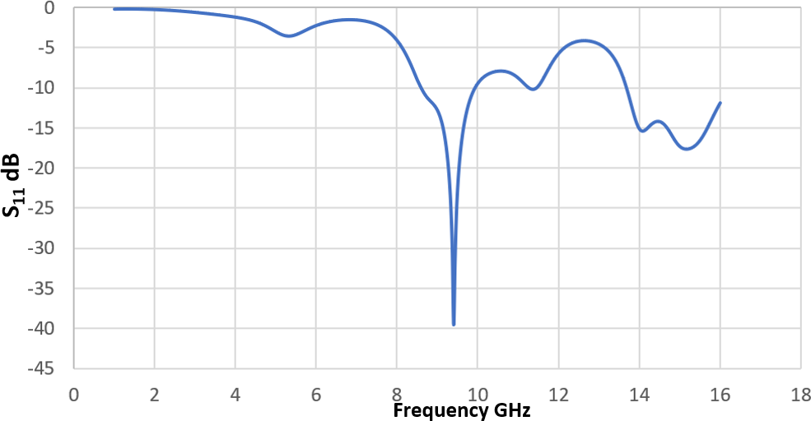

Figure.6.4 Return loss for Iteration-2

Antenna design with DGS

In the 3rd Iteration DGS is introduced on the ground plane shown in figure.6.5 which operates at frequency range 3.24-14.6GHz. Thus, optimized results are observed for the proposed antenna b considering DGS shown in figure.6.6.

Figure.6.5 Proposed antenna with DGS (Iteration-3)

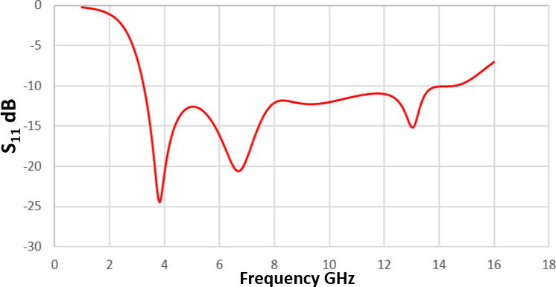
Figure.6.6 Return Loss for proposed antenna with defected ground The recursive process of designing the proposed antenna is carried out by changing iteration-1 to iteration-3 to obtain high impedance bandwidth shown in Fig.6.7. Parametric analysis was carried out for different iterations of the proposed antenna and comparative variations of return loss for design iterations (1), (2), (3) are illustrated in Fig.6.8. A significant increase in the frequency band has been observed from one iteration to the next. The frequency spectrum covered by the iteration (3) is from 3.24 GHz to 14.6 GHz.
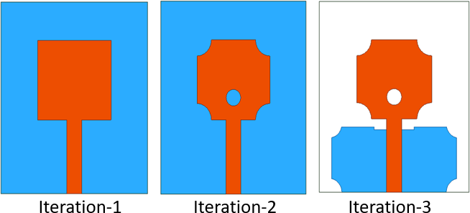

Figure.6.7 Schematic configuration of Iterations-1,2,3
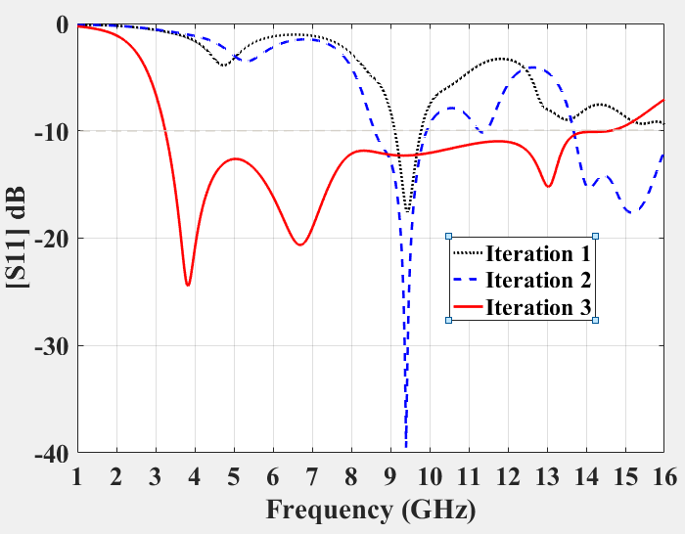
Figure.6.8 Simulated Return loss for different iterations (1, 2, 3)

PARAMETRIC ANALYSIS:
The parametric analysis is used to analyze the characteristics of proposed antenna for ultra-wideband with improved impedance bandwidth. The variability of the gap between the radiating patch and DGS, Strip feed width, the inner radius R1 and the use of various substrates is used to evaluate the performance of the proposed antenna for various parametric values.

Return loss curve with various DGS
To enhance the bandwidth various defected ground structures are used. The following describes about the DGS with different shapes.

Antenna design with circular slit DGS
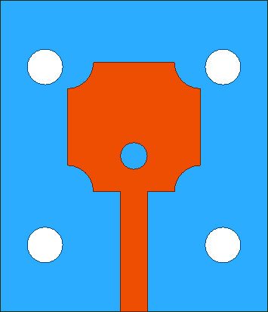
In the antenna design, a defected structure is introduced to enhance the bandwidth. Here, a circular slot with radius 2mm is at 4 positions shown in figure.6.9. Thus, the antenna operates at frequency range 8.56-9.88GHz. The return loss for circular slit DGS is shown in figure.6.10.

Figure.6.9 Circular slit DGS
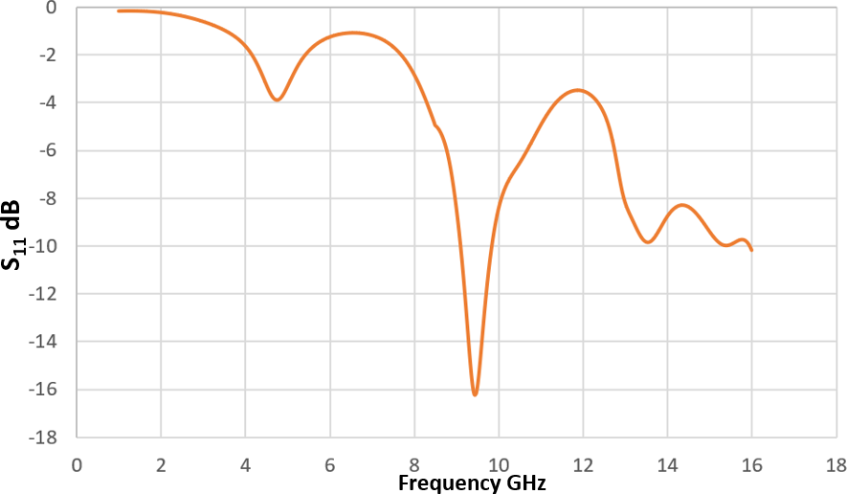
Figure.6.10 Return loss for circular slit DGS

Antenna design with triangular slit DGS

In the antenna design, a defected structure is introduced to enhance the bandwidth. Here, a triangular slot with radius 2mm is at 4 positions shown in figure.6.11. Thus, the antenna operates at frequency range 8.21-9.98GHz. The return loss for triangular slit DGS is shown in figure.6.12.

Figure.6.11 Triangular slit DGS
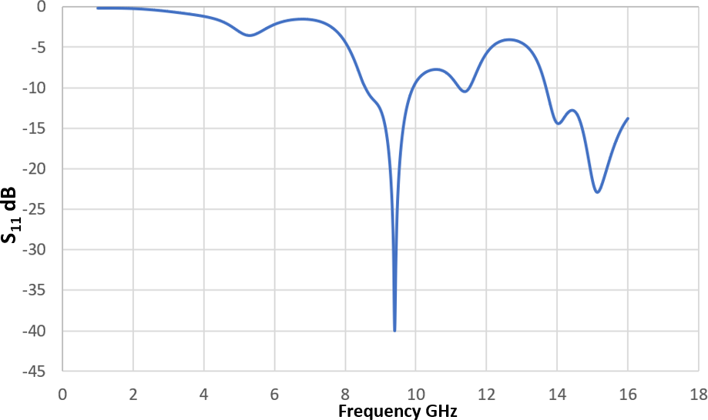
Figure.6.12 Return loss for triangular slit DGS

Antenna design with Proposed DGS
In the antenna design, a defected structure is introduced to enhance the bandwidth. Here, a circular slot with radius 2mm is at each corner of ground and a rectangular slot on the ground plane as shown in figure.6.13. Thus, the antenna operates at frequency range 3.24- 14.6GHz. The return loss for Proposed DGS is shown in figure.6.14.



Figure.6.13 Proposed DGS

Figure.6.14 Return loss for Proposed DGS
The parametric analysis is performed by introducing circular and triangular slots as shown in figure.6.15(a). The Proposed Antenna gives optimized results with various DGS shown in Figure.6.15(b).
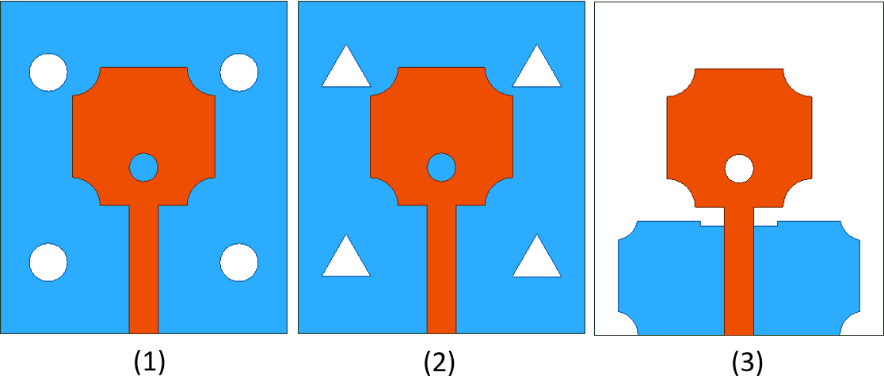

Figure.6.15 (a) Antenna with various DGS (1) Circular slots (2) Triangular slots (3) Proposed Antenna

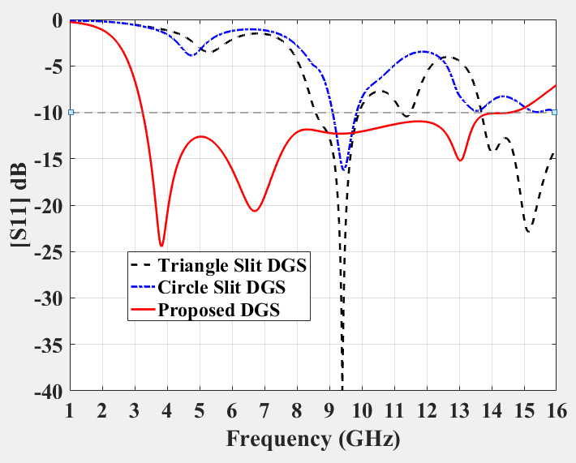
Figure.6.15(b) Simulated return loss for various DGS

Return loss curve with and without DGS
Parametric analysis was performed with and without DGS, as shown in Figure.6.16. The inclusion of the DGS in the Proposed Antenna resulted in improved impedance bandwidth observed in the following figure. The rectangular patch antenna can be modified by introducing circular slots at each corner of the patch and the ground appeared in figure.6.13. The bandwidth of proposed antenna is operating from 3.24 -
14.6 GHz below -10dB.
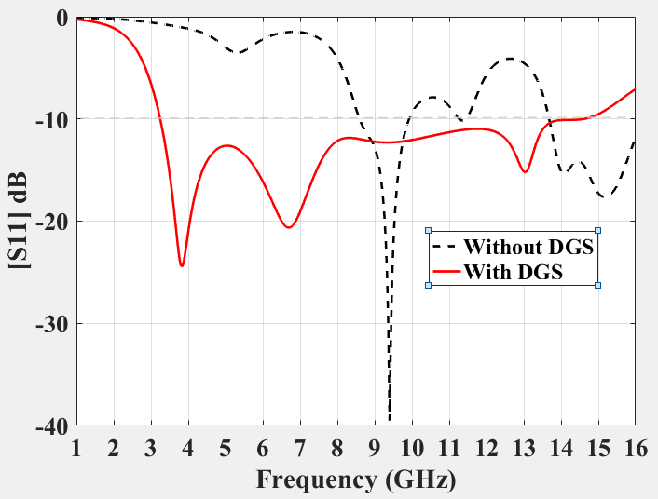

Figure.6.16 Simulated Return loss with and without DGS
    - Return loss curve due to variation in Gap (g)
The parametric variation is made by varying the Gap g between the Defected ground structure (DGS) and the radiating patch shown in Figure.6.17. Due to variation of gap, we can observe that the return loss also varies and at particular gap we can check where the maximum

bandwidth can be obtained. For Gap g=1.5 optimized results were observed.
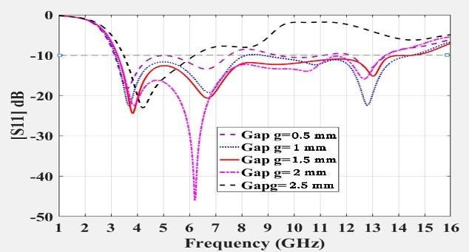

Figure.6.17 Simulated return loss curves due to variation of Gap(g)
    - Return loss curve due to variation in inner radius R1
The parametric variation made by varying the inner radius R1 is shown in Figure.6.18. In the design of antenna, a circular slot is introduced in the rectangular patch and assigning parametric setup in simulation process to understand where the optimum bandwidth is achieved for different values of radius of inner circular slot. The frequency spectrum covered for inner radius R1 = 1.5mm is between 3.24 GHz and 14.6 GHz. Thus, optimized results were observed for R1 = 1.5mm.
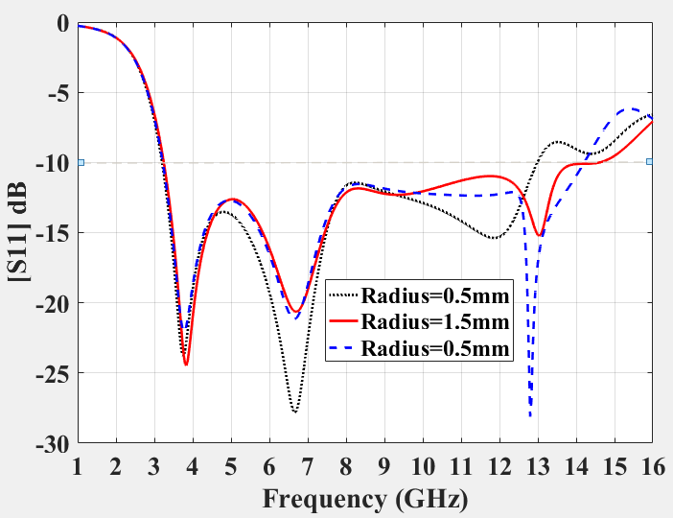

Figure.6.18 Simulated Return loss for variation of inner radius R1

Return loss curve for Various Substrates
The parametric variations of proposed antenna structure with various substrates are simulated namely with FR4 epoxy (εr=4.4), RT Duroid (εr=2.2) and Teflon (εr=2.1) shown in Figure.6.19. FR 4 epoxy

substrate have exhibited comparatively better performance when compared with Rogers RT Duroid and Teflon.
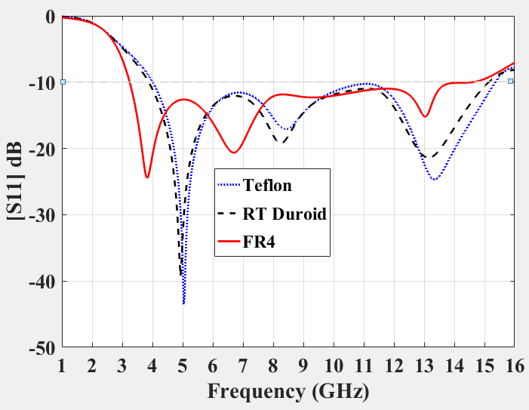

Figure.6.19 Simulated results for various Substrates
    - Return loss curve due to variation in Strip feed width Wf
Bandwidth can also be improved by varying width of the feed and different feed widths are considered to analyse the designed antenna shown in Figure.6.20(a). The parametric analysis is performed by varying the width of feed strip Wf for different widths, namely 1 mm, 2 mm and 3 mm is illustrated in Figure.6.20(b).
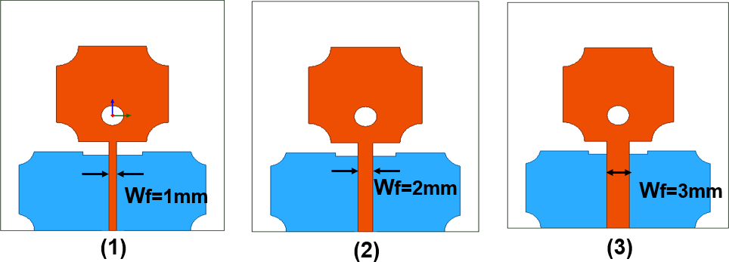

Figure 6.20 (a) Different feed widths
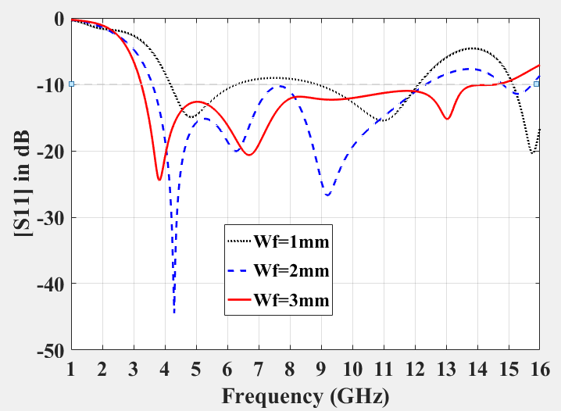
Figure.6.20 (b) Simulated return loss for various feed width Wf
Optimized results were observed for a width of 3 mm strip feed.

Table.6.1: Parametric Performance analysis of various parameters variation
Parameter Variation |  | Frequency  band (GHz) | Impedance  Bandwidth (%) | Peak Gain  (dB)
Iteration | 1 | 9.1-9.7 | 6.38 | 2
 | 2 | 8.4-9.8 | 16 | 3
 | 3 | 3.24-14.6 | 127.35 | 9.78
Gap g (mm) | 0.5 | 3.48-6.21 | 56 | 2.2
 | 1.0 | 3.25-13.5 | 119 | 3.3
 | 1.5 | 3.24-14.6 | 127.35 | 9.78
 | 2 | 3.18-8.76 | 93 | 4.2
 | 2.5 | 3.13-12.13 | 117 | 3.2
Inner radius R1 (mm) | 0.5 | 3.21-12.98 | 120 | 2.4
 | 1.5 | 3.24-14.6 | 127.35 | 9.78
 | 2.5 | 3.22-14.2 | 126 | 3.3
Width of | 1 | 4.18-6.26, | 39, | 2.1
Strip feed |  | 8.86-12.1 | 30
Wf (mm)
 | 2 | 3.6-12.33 | 109 | 4.3
 | 3 | 3.24-14.6 | 127.35 | 9.78
Teflon | εr= 2.1 | 4.01-15.34 | 117 | 3.2
RT Duroid | εr= 2.2 | 3.88-15.13 | 118 | 4.5
FR 4 | εr= 4.4 | 3.24-14.6 | 127.35 | 9.78
Without DGS |  | 8.6-9.8 | 13 | 4.8
With DGS |  | 3.24-14.6 | 127.35 | 9.78

VSWR
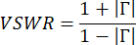
VSWR stands for Voltage Standing Wave Ratio which is a function of the reflection coefficient, which describes the amount of reflected power from the antenna. If the reflection coefficient is given by Γ, then VSWR is defined as

Return loss is referred to as reflection coefficient or S11. VSWR is always a positive and real number for antennas. When the VSWR value is smaller it indicates that the antenna is matched to the transmission line and more power is supplied to the antenna. As shown in figure.6.21 VSWR value lies between 1 and 2 for an entire frequency band. Thus, the amount of reflection takes place will be very less.
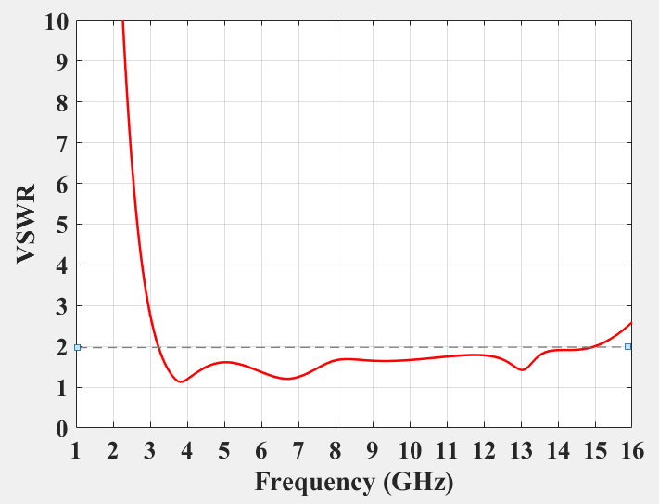

Figure.6.21 Simulated VSWR

PEAK GAIN
The simulated peak gain for proposed antenna design is shown in Figure.6.22. It can be observed that the maximum peak gain achieved is
9.78 dB at 11.96 GHz.
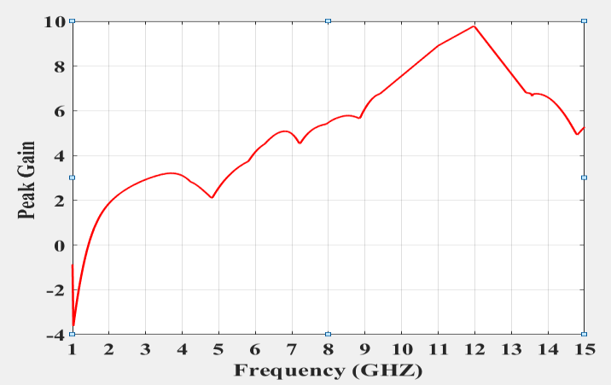

Figure.6.22 Peak Gain (dB) vs Frequency (GHz)
  - SURFACE CURRENT AND FIELD ANALYSIS
The surface current analysis of the proposed antenna is shown in Figure.6.23. The E-field & H-field distribution of the proposed antenna are shown in Figure.6.24.

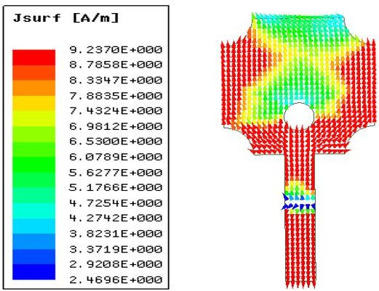
Figure.6.23 Simulated Surface current distribution
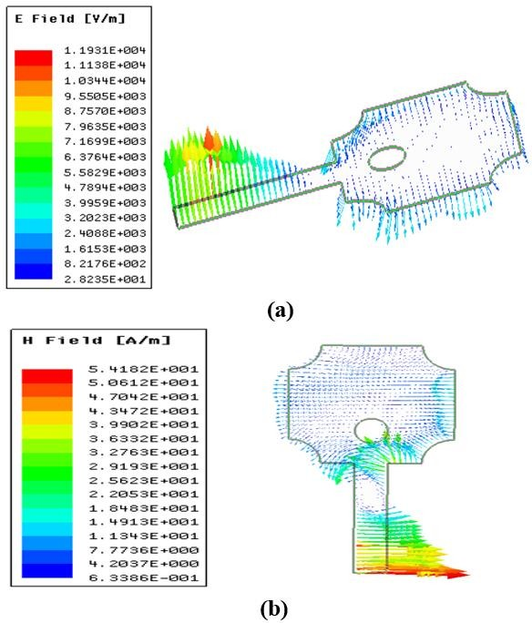
Figure.6.24 Simulated (a) E-field (b) H-field distribution

MEASURED RESULTS AND DISCUSSIONS
The top and base perspective on fabricated antenna is appeared in Figure.6.25. The fabricated antenna is tested using Anritsu MS2037C/2 Vector Network Analyzer. The return loss for both measured and simulated results are analysed for proposed antenna is appeared in Figure.6.26.

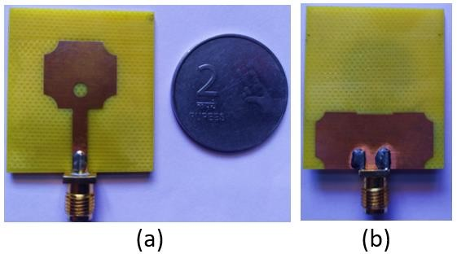

Figure.6.25 Fabricated Antenna (a) Top view (b) Bottom view
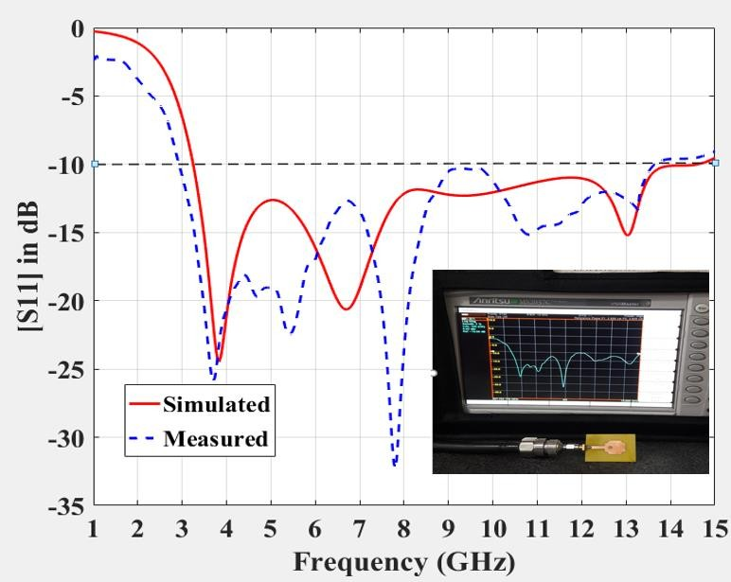

Figure.6.26 Measured and simulated return loss for proposed antenna
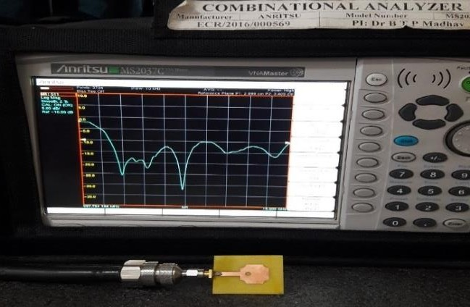

Figure.6.27 Fabricated antenna result using VNA

The far field radiation pattern of proposed antenna is bidirectional shown in Figure.6.27. The simulated plots E and H fields of proposed antenna taken at 3.86GHz, 6.7GHz, 9.4 GHz, 13GHz respectively.

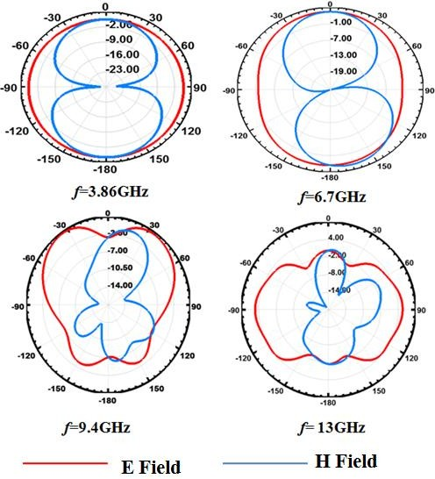

Figure.6.28 Simulated radiation pattern of proposed antenna at 3.86GHz, 6.7GHz, 9.4 GHz and 13GHz
Table.6.2: Comparative analysis of proposed antenna with previously reported antennas in literature

Reference | Antenna size  (mm2) | Frequency band  (GHz) | Impedance  Bandwidth (%)
[26] | 18 × 21 | 3.58-9.93 | 94
[28] | 57 × 46 | 3.4-5.7 | 52
[22] | 50 × 42 | 2.4-10.4 | 125
[17] | 45 × 30 | 2.4-9.28 | 117
[25] | 50 × 42 | 2.4-9.8 | 117
[24] | 50 × 42 | 2.5-10.68 | 126.15
Proposed | 30 × 35 | 3.24-14.6 | 127.35

CONCLUSION

In this chapter, the characteristics of the proposed antenna are observed along with measured results, return loss, radiation pattern, VSWR measurement, peak gain, surface current and analysis.

CHAPTER 7 CONCLUSION & FUTURE SCOPE

CONCLUSION

Hence a microstrip patch antenna is designed which works under different frequencies. The substrate used here is FR4 epoxy having relative permittivity of ℇr=4.4. The enhancement of bandwidth is achieved by introducing DGS, modifying shape of the patch. Thus, the improvement is accomplished for compact microstrip patch antenna structure.
In this thesis, a novel compact rectangular microstrip patch antenna with DGS is proposed. The optimized dimensions of the proposed antenna were realized, fabricated and tested used for obtaining good impedance matching along with improvement in Bandwidth. Operating frequency range of 3.24GHz to 14.6GHz was observed for the designed antenna which is appropriate for wireless applications such as WLAN, WiMAX, C- band, X-band and lower frequencies of Ku-band and having an impedance bandwidth of 127.35%. The simulated results are observed and compared with measured results for the proposed antenna.

FUTURE SCOPE

The future scope of our project is that we can make the microstrip antenna work at number of frequencies. Additionally, we can improve the bandwidth by utilizing various defected ground structures and also, we can reduce the size of the antenna to operate at same number of frequencies as mentioned in this project.

REFERENCES

    - Abdolmehdi Dadgarpour, Amin Abbosh and Farid Jolani, “Planar Multiband Antenna for Compact Mobile Transceivers”, IEEE Antennas and Wireless Propagation Letters, 2011.
    - Amiya B. Sahoo, AyushBiswal, Chandan K. Sahu, Jogesh C. Dash and B.B. Mangaraj, “Design of Multi-band Rectangular Patch Antennas using Defected Ground Structure (DGS)”, IEEE International Conference on Recent Trends in Electronics Information & Communication Technology (RTEICT), May 19-20, 2017.
    - Asmita Mhamane and Meenakshi Pawar, “Designing of wideband Microstrip patch antenna for wireless applications”, International Journal of Computer Applications (IJCA), 2013.
    - Bhanu Priya Kumawat, Santosh Meena and Sanjeev Yadav, “Square Shape Slotted Multiband Microstrip Patch Antenna Using Defect Ground Structure”, IEEE, International Conference on Information, Communication, Instrumentation and Control (ICICIC), 2017.
    - Bharatendra Singh Niboriya, Chetan Choudhary and Gyan Prabhakar, “S-shape Wideband Microstrip Patch Antenna with Enhanced Gain and Bandwidth for Wireless Communication”, International Journal of Computer Applications Volume 73– No.7, 2013.
    - Bharatendra Singh Niboriya and Chetan Choudhar, “S-shape Wideband Microstrip Patch Antenna with Enhanced Gain and Bandwidth for Wireless Communication”, International Journal of Computer Applications, 2013.
    - D.D. Ahire and G.K. Kharate, “Defective Ground Corner Rounded Ultra-Wideband Microstrip Patch Antenna for Bio-Medical Applications”, Ictact journal on microelectronics,2018.
    - Deependra Khandelwal, Ajay Patidar and Banwari Lal Kalwar,
“Multi-frequency Wideband Microstrip Patch Antenna for WLAN/

HIPERLAN/ SATELLITE Applications”, International Journal of Scientific Research Engineering & Technology, 2012.
    - Dheeraj Mungur and Shankar Duraikannanz, “Microstrip Patch Antenna at 28 GHz for 5G Applications”, Journal of Science Technology Engineering and Management-Advanced Research & Innovation, 2018.
    - G. Singh, R. Rajni and R.S. Momi, “Microstrip Patch Antenna with Defected Ground Structure for Bandwidth Enhancement”, International Journal of Computer Applications, Vol. 73, No. 9, pp. 14- 18, 2013.
    - Gazala Pravin and A. K. Rastogi, “Low cost microstrip patch antenna array for wireless communications”, JETIR 2018.
    - Houda Werfelli, Khaoula Tayari, Mondher Chaoui, Mongi Lahiani and Hamadi Ghariani, “Design of Rectangular Microstrip Patch Antenna”, 2nd International Conference on Advanced Technologies for Signal and Image Processing –2016.
    - Jeevani W. Jayasinghe and Omar A. Saraereh, “Bandwidth optimization of an Ultra-Wide Band Microstrip Antenna”, International Conference on Communication, Information & Computing Technology (ICCICT) ,2017.
    - Jigar M. Patel, Shobhit K. Patel and Falgun N. Thakkar, “Defected Ground Structure Multiband Microstrip Patch Antenna using Complementary Split Ring Resonator”, International Journal of Emerging Trends in Electrical and Electronics (IJETEE – ISSN: 2320-9569) Vol. 3, Issue. 2, May-2013.
    - Jing Pei, An-Guo Wang, Shun Gao, Wen Lang, “Miniaturized Triple- Band Antenna with a Defected Ground Plane for WLAN/WiMAX Applications”, IEEE Antennas and Wireless Propagation Letters, 2011.
    - K.G Jangid, Ajay Tiwari, V.S Kulhar, Vijay Sharma, V.K Saxena and D. Bhatnagar, “Circular Patch Antenna with Defected Ground for UWB Communication with WLAN Band Rejection”, Defence Science Journal, Vol. 66, No. 2, pp. 162-167, 2016.

    - Karishma D. Girase and Mandar P. Joshi, “Design of Wideband Monopole Square microstrip patch antenna”, International Conference on Communication, Information & Computing Technology (ICCICT) ,2016.
    - L. H. Weng, X. W. Shi, Y. C. Guo, and X. Q. Chen," An Overview on Defected Ground Structure", Electromagnetic Research, Vol. 7, 173-189, 2008.
    - M. Gunavathi, P. Ramya, D. Kavitha and P. Hamsagayathri, “Design and simulation of miniaturized UWB microstrip patch antenna for wireless communication”, International Research Journal of Engineering and Technology (IRJET), 2016.
    - MHD Amen Summakieh and Mastaneh Mokayef, “Single Wideband Microstrip Patch Antenna for 5G Wireless Communication Application”, Journal of Electrical and Electronics Engineering- IJRDO, 2016.
    - Mohammad Ojaroudi and Nasser Ojaroudi, " Ultra-Wideband Small Rectangular Slot Antenna with Variable Band-Stop Function", IEEE Transactions On Antennas And Propagation, VOL. No 62, January 2014.
    - Neha Tanzeem Sagar, M. L. Meena and Pankaj Shukla, “Design and Performance Analysis of Uwb Circular Ring Antenna with Defected Ground Structure”, 2017.
    - P. Rakesh Kumar, A. Gurava Reddy, K. Satya Prasad, “Equivalent Circuit Model of Novel Tri-Band Defected Ground Structure based Patch Antenna for Wi-Max/WLAN Applications”, 2017.
    - P. Rakesh Kumar, K. Satya Prasad, A. Guruva Reddy, "Design of analysis of wideband Hexagonal circular ring patch antenna using Defected Ground Structure", Journal of Advanced Research in Dynamical and control systems, ISSN:1943-023X, Volume 2, page No 1037-1145,2019.
    - P. Rakesh Kumar, K.V.N. Kavya, “Design and Performance Analysis of Wideband Hexagonal Ring Antenna with Defected Ground Structure”, International Journal of Innovative Technology and Exploring Engineering (IJITEE),2019.

    - Praveen Nartam, Subhajit Chatterjee and Abhijeet Gulawani, “Design of an Ultra Wide Band Antenna using Defected Ground Structure”, International Conference on Computation of Power, Energy Information and Communication (ICCPEIC) 2016.
    - Radouane Karli and Hassan Ammor, “A Simple and Original Design of Multi-Band Microstrip Patch Antenna for Wireless Communication”, International Journal of Microwaves Applications, March – April 2013.
    - Rahul Suvalka, Santosh Agrahari and Amit Rathi, “Design Planar Microstrip Antenna for Wireless and Lower UWB Applications Using DGS”, IEEE International Conference on Recent Advances and Innovations in Engineering (ICRAIE-2016).
    - Rama Krishna Guttula, Venkateswara Rao Nandanavanam, “Design and Analysis of Ultra Wideband Octagonal Circular Ring Patch Antenna using Defected Ground Structures”, International Journal of Advanced Science and Technology Vol. 29, No.02, (2020), pp. 2265-2276.
    - S. A. Shelke, and V. U. Deshmukh, “Dual-Band Microstrip Patch Antenna for Wireless Application”, International Journal of Scientific Research in Science and Technology, 2016.
    - S. Sivagnanam, Dr.E. Gnanamanoharan, Dr. P. kailasapathi, “Multislot Rectangular Patch antenna with Defected Ground Structure for UWB Wireless Applications”, 2019.
    - S. Taha Imeci, Derya Arican and Hakan Hizarcioglu, “Wideband Microstrip Patch Antenna at 7 GHz”, 27th Annual Review of Progress in Applied Computational Electromagnetics, 2011.
    - S. Sri Harsha, S. Aravind Kishore and U. Rajesh, “Microstrip patch antenna using UWB for wireless communication devices”, 3rd international conference on recent innovations in science engineering and management, 2016.
    - Shenario Ezhil Valavan and Peter Knott, “Improving Bandwidth of Planar Microstrip Patch Array Antennas”, international conference Nurnberg, Germany 2015.

    - Sourabh Bisht, Shweta Saini, Bhaskar Nautiyal and Dr. Ved Prakash, “Study the Various Feeding Techniques of Microstrip Antenna Using Design and Simulation Using CST Microwave Studio”, International Journal of Emerging Technology and Advanced Engineering, ISSN 2250-2459, ISO 9001:2008 Certified Journal, Volume 4, Issue 9, September 2014.
    - Vivek Singh Rathor and Jai Prakash Saini, “A Design of Swastika Shaped Wideband Microstrip Patch Antenna for GSM/WLAN Application”, Journal of Electromagnetic Analysis and Applications, 2014.
    - Vyshnavi Das S, T. Shanmuganantham, “Design of Multiband Microstrip Patch Antenna For IOT Applications”, Proceedings of 2017 IEEE International Conference on Circuits and Systems (ICCS), 2017.
    - Wen-Chung Liu, Yang Dai and Chao-Ming Wu, “Design of Triple- Frequency Microstrip-Fed Monopole Antenna Using Defected Ground Structure”, IEEE Transactions on Antennas and Propagation, July 2011.
    - Y.F. Cao, S.W. Cheung and T.I. Yu, “A Multiband Slot Antenna for GPS/WiMAX/WLAN systems”, IEEE Transactions on Antennas and Propagation, 2015.
    - Youssef Rhazi, Youssef El merabet, Outman El Bakkali, Mustpaha Ait lafkih, Seddik Bri and Mohamed Nabil Srifi, “Novel Design of Multiband Microstrip Patch Antenna for Wireless Communication”, Advances in Science, Technology and Engineering Systems Journal Vol. 4, No. 3, 63-68 (2019).
    - “Antenna theory: Analysis and Design”, by Constantine A. Balanis.
    - “Antennas and Wave Propagation”, 4th Edition by Ronald J
Marhefka, John D Kraus, Ahmad S Khan.
    - “Microstrip Antennas: The Analysis and design of Microstrip
antennas and arrays”, by David M. Pozar, Daniel H. Schaubert.
    - “Ansoft HFSS-User Guide 3rd Edition”, by ANSYS, Inc.Proprietary.

